**MATHEMATICS 30-1**

Course Syllabus

Mrs. Orchard – Semester I, 2019-20

Name:___________________________

**Course Schedule**

|  |  |  |
| --- | --- | --- |
| **UNIT** | **CLASSES** | **EXAM DATES**  **(may vary slightly) MARK %** |
|  |  |  |
| 1. Transformations and Functions; Radical Functions (Ch 1&2) | 13 | September 20 _______ |
|  |  |  |
| 2. Polynomial Functions (Ch 3) | 8 | October 3 _______ |
|  |  |  |
| 3. Rational Functions; Function Operations (Ch 9 & 10) | 10 | October 22 _______ |
|  |  |  |
| 4. Exponents and Logarithms (Ch 7 & 8) | 11 | November 7 _______ |
|  |  |  |
| 5. Trigonometry: unit circle, functions, graphs (Ch 4 & 5) | 9 | November 28 _______ |
|  |  |  |
| 6. Trigonometric Identities (Ch 6) | 12 | December 18 _______ |
|  |  |  |
| 7. Permutations and Combinations (Ch 11) | 11 | January 17 _______ |
|  |  |  |
|  |  |  |
|  |  |  |
| **DIPLOMA EXAM** |  | Thursday, January 23 |
|  |  |  |
| Note: English Part A January 13, Social Part A January 14 |  |  |
|  |  |  |
|  |  |  |
|  |  |  |

**Note: This syllabus is available on my microsite page. Contact info:** [**alice.orchard@eips.ca**](mailto:alice.orchard@eips.ca)

**Course Description**

Mathematics 30-1 builds on key concepts from Mathematics 20-1. Learning through problem solving is the key focus. Students develop and refine their own way of solving problems and show their work in a variety of ways. Students use mathematical vocabulary to explain how they solve problems and continue to acquire the mathematical processes of communication, making connections, mental mathematics, and visualization, and the use of technology as a tool.

Students who believe they can learn, take risks and persevere in problem solving will be successful mathematics students.

The topics in Mathematics 30-1 include:

* Trigonometry: develop trigonometric reasoning
* Relations and Functions: develop algebraic and graphical reasoning through the study of relations
* Permutations, Combinations and Binomial Theorem: develop algebraic and numeric reasoning that involves combinatorics

**Evaluation**

There will be a unit exam after each unit. In addition to the 7 unit exams, assignments designed to promote understanding will occur throughout the course**.**

Opportunity to improve an exam mark will be offered at specified points throughout the semester. Rewrite opportunities will be at the teacher’s discretion after you have filled out a re-write form and have displayed evidence of practice and attention to further your learning. **Staying on task and keeping pace with the class is important**. With this in mind, UNIT STUDY NOTES should be presented to me **prior** to each unit exam in order for me to consider granting a re-write opportunity.

The mark you achieve in class will be worth 70% of your final Math 30-1 mark, leaving the Diploma exam worth 30% of your final mark.

|  |  |  |
| --- | --- | --- |
| **Categories** | **Chapters in Text** | **Weight (%)** |
| Relations and Functions | 1: Transformations  2: Radicals  3: Polynomials  9: Rationals  10: Operations & Compositions | 41 |
| Exponents and Logarithms | 7: Exponents  8: Logarithms | 15 |
| Trigonometry | 4: Trigonometry and the Unit Circle  5: Trigonometric Functions  6: Trigonometric Identities | 29 |
| Perms Combs and Bin. Thm | 11: Perms, Combs, Binomial Theorem | 15 |

**Exams and assignments**

1. If you are absent for an exam, you are required to write the exam **upon your return** at an agreed upon time and location.
2. Please be aware that everything counts. All work assigned (assignments, quizzes, exams) may be used to determine your grade in this course. Once an assignment or quiz is handed back to the students, any late assignments will not be accepted for the purpose of assessment.

**Required Materials**

Pre-Calculus 12 textbook & workbook, a binder, a pencil, and a graphing calculator. ***The Key*** is a booklet that contains an ample amount of previous Diploma questions and solutions to help you prepare for the Diploma Exam. There are also a number of useful websites that include video explanations available.

**Classroom Expectations**

1. **Give your best effort every day; ask questions when you don’t understand. DO NOT FALL BEHIND!**
2. Attend class regularly.
3. Conduct yourself in a **courteous**, **respectful** manner and comply with all school rules listed in the online student agenda.
4. If you are late, get a late slip and enter the room in a respectful manner.
5. Use washrooms before class begins.
6. Be sitting at your desk when the bell rings.
7. Bring your required materials to class every day.
8. Please refrain from consuming any food or drink during the entire class, with the exception of water.
9. Not use personal electronics (phones, music, games) unless directed to do so. It is expected that your personal device will be left in your locker or in the red pouch during class.
10. Review notes and class work every night and complete homework as assigned.

**DO NOT PRACTICE UNTIL YOU GET IT RIGHT. PRACTICE UNTIL YOU DON’T GET IT WRONG.**

1. Preparation to leave the classroom at the end of the period includes ensuring that your work area is neat.

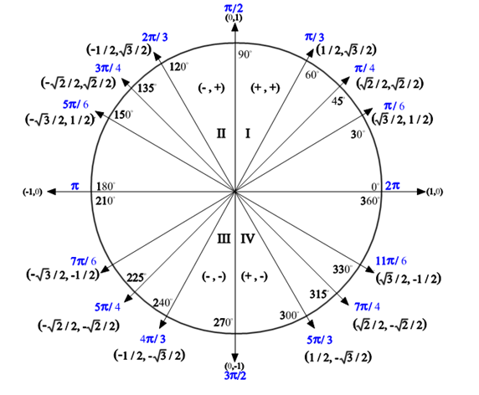

Period for sine and cosine: 360o or 2π

Period for tangent: 180o or π

In an equation:

period =  (for degrees) period =  (for radians)

**Transformations of Trigonometric Functions**

**y =** asin[b(x - c)] + d

**horizontal**

**translation**

(Phase shift)

-just like before

**vertical**

**translation**

(Vertical

displacement)

-just like before, PLUS, it cuts the graph in half horizontally...good to know!

**horizontal stretch**

by a factor of 1/b

value of **b** HELPS

you find the **period**

**('b' is NOT the**

**period!!!!!!)**

**amplitude**

(vertical stretch by a

factor of 'a')

Amplitude = max - min

2

Think: distance away

from 'centre line', which

is the **value of 'd'**

**\*\*Reflection: -a, +a**

|  |  |
| --- | --- |
| **Interval Notation:** (description) | (diagram) |
| Open Interval:   (*a, b*)  is interpreted as *a < x < b* where the endpoints are NOT included. (While this notation resembles an ordered pair, in this context it refers to the interval upon which you are working.) | (1, 5) http://www.regentsprep.org/Regents/math/ALGEBRA/AP1/openintervalpic2.gif |
| Closed Interval:  [*a, b*]  is interpreted as *a < x < b*  where the endpoints are included. | [1, 5] http://www.regentsprep.org/Regents/math/ALGEBRA/AP1/closedintervalpic2.gif |
| Half–Open Interval:  (*a, b*]  is interpreted as *a < x < b* where a is not included, but b is included. | (1, 5] http://www.regentsprep.org/Regents/math/ALGEBRA/AP1/halfintervalpic2.gif |
| Half–Open Interval:  [*a, b*) is interpreted as *a < x < b* where a is included, but b is not included. | [1, 5) http://www.regentsprep.org/Regents/math/ALGEBRA/AP1/halfintervalpic3.gif |
| Non–ending Interval: $(a,∞$ ) is interpreted as *x > a* where *a* is not included and infinity is always expressed as being "open" (not included). | http://www.regentsprep.org/Regents/math/ALGEBRA/AP1/infiniteinterval.gif |
| Non–ending Interval: $\left(-∞,b\right]$  is interpreted as *x < b* where *b* is included and again, infinity is always expressed as being "open" (not included). | http://www.regentsprep.org/Regents/math/ALGEBRA/AP1/infiniteinterval2.gif |

