**MATH 10C UNIT 1** **REVIEW** (Chapter 2 – Trigonometry)

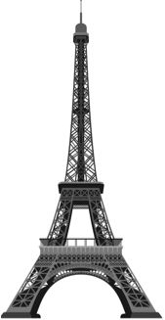

Third level

Antenna

80.6˚

82.1˚

45 m

NOT TO SCALE

1. From a point 45 m from the centre of the base, the angles of elevation of the top of the antenna and the third level of the Eiffel Tower are 82.1˚ and 80.6˚ respectively. Find the height of the tower (to the top of the antenna) and the height of the antenna above the third level.

____________________

____________________

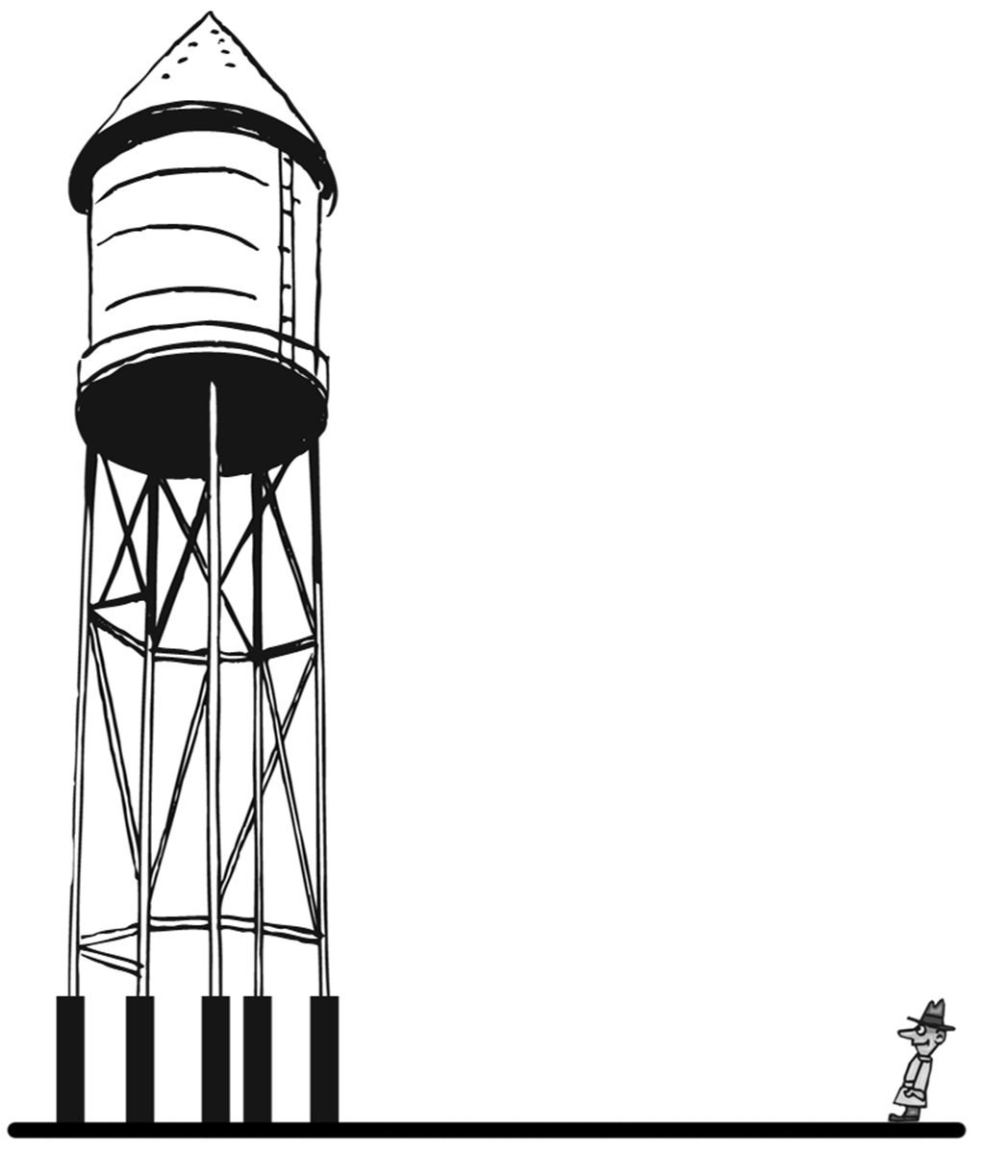

2. Stanley stands 72 feet from the centre of the base of a 110-foot high water tower, as sketched to the right. What is the angle of elevation from Stanley’s position to the top of the tower?



____________________

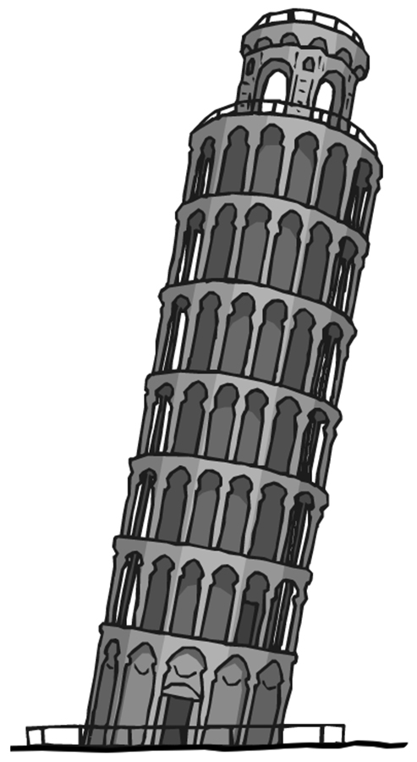

3. The Leaning Tower of Pisa (at right) has a top balcony that is 56.7 m above the base of the tower (measured along the side of the tower.) At its maximum lean, the angle the tower made with the ground was 84.5˚. If a rock is dropped from the top balcony on the low side, how far would the rock fall?

____________________

25 cm

*x*

41˚

4. Find the missing side *x* in each triangle.

32˚

4.5 yd

*x*

a) b) c)

61˚

130 m

*x*

____________________ ____________________ ____________________

5. Find the missing angle indicated in each triangle.

480 km

610 km

A

B

C

11 ft

22 ft

A

B

C

92 cm

124 cm

A

B

C

a) b) c)

____________________ ____________________ ____________________

Canyon width

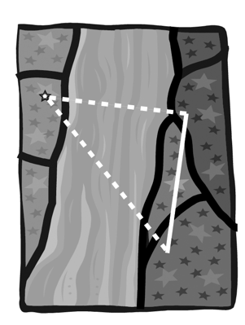

Survey marker

Baseline

Surveyor’s location

6. A surveyor and her assistant use a transit to sight a survey marker on the far side of a deep canyon. They then swing a 90.0˚ angle to establish a baseline direction, then measure 1.60 km along the baseline. At the far end of the baseline, they again sight the survey marker. The angle between the baseline and the line to the marker is 47.0˚. How wide is the canyon?

____________________

7. The sketch shows a cell phone tower with four guy wires, each attached to the ground at a point 8.5 m from the base of the tower. The shorter wires are 20.0 m long, and the longer wires are 24.0 m long. Find the angle of elevation of each guy wire. Also find how far apart are the points of attachment of the wires to the tower.

Guy wires

_______________

_______________

_______________

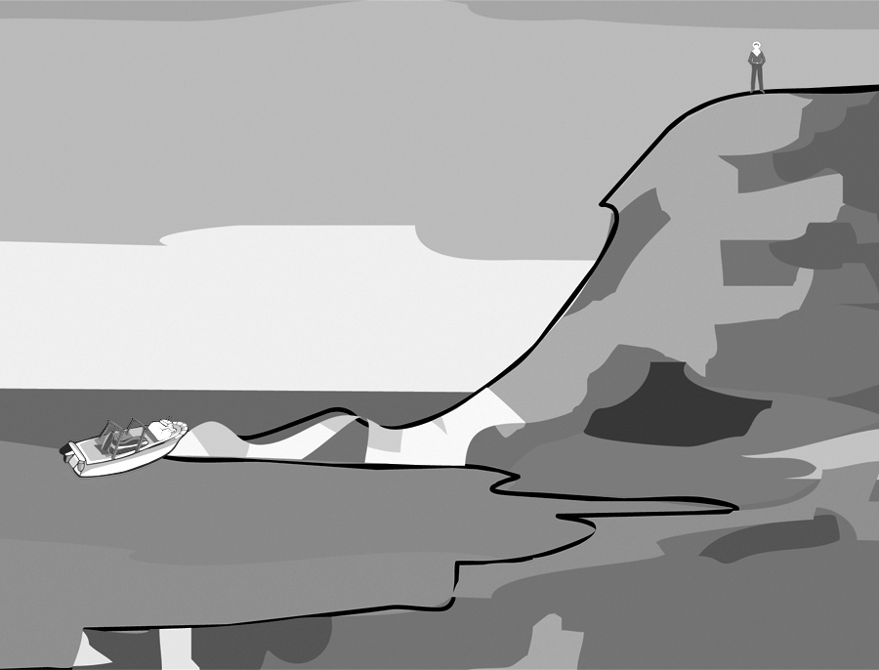8. As sketched at right, a sailor lands his small powerboat on an outcropping at the base of a 130-foot high cliff. He then hikes to the top of the cliff. The angle of depression from his point on the top of the cliff back down to his boat is 37˚. How far is he (in a direct line) from his boat?

____________________

9. Jim is at work as a window washer, working his way up a tall office building. His younger brother Jeb watches from the street below, and uses an inclinometer to measure angles of elevation to Jim’s positions. At the fourth floor, Jeb measures an angle of 45˚ and at the ninth floor, an angle of 66˚. If Jeb is standing 12 m from the base of the building, find the height of the ninth floor windows, and the distance between the fourth and ninth floors.

____________________

____________________

10. Solve each triangle completely.

610 km

X

Y

Z

35.0˚

36 cm

21 cm

A

B

C

7 ft

8 ft

P

Q

R

a) b) c)

____________________ ____________________ ___________________

____________________ ____________________ ___________________

____________________ ____________________ ___________________

11. Find the indicated side or angle.

2.5 m

4.0 m

X

74˚

15 in

*x*

68˚

22˚

a) b)

____________________ ____________________