**Unit 1 Quadratic Functions and Equations Final Exam Review**

**1.** For a quadratic function, which characteristic of its graph is equivalent to the zeros of the function?

**2.** Identify the *y*-intercept of the graph of this quadratic function: y = -7 (x – 5)2 + 8

**3.** Use a graphing calculator to determine the *x*-intercepts of the quadratic function y = 6x2 – 27x - 12 Write the intercepts to the nearest hundredth, if necessary.

**4.** A rectangular horse coral is to be enclosed with 80 m of fencing. The area of the horse coral, *A* square metres, is modelled by the function A = 40x – x2, where *x* is the width, in metres. What is the width that gives maximum area? Write the answer to the nearest tenth, if necessary.

**5.**  If the graph of a quadratic equation has one x – intercept, what is a possible value of the discriminant?

**6.** Describe the translation that would be applied to the graph of  to get the graph of y = x2 + 5?

**7.** Describes the translation that would be applied to the graph of  to get the graph of y = (x - 15)2?

**8.** Which statement is NOT true for the graph of ?

|  |  |
| --- | --- |
| **A.** | When *a* is greater than 1, the graph is the image of the graph of  after a vertical stretch (becomes more narrow). |
| **B.** | When *,* the graph is the image of the graph of  after a vertical compression (widens) . |
| **C.** | The vertex of the graph is never at the origin. |
| **D.** | When *a* is less than , the graph is the image of the graph of  after a vertical stretch and a reflection in the *x*-axis. |

**9.** Expand the quadratic function y = 4 (x – 9)2 -2 and write in general form?

**10.** A wide screen TV has a diagonal measure of 55 inches. The length of the screen is 24 inches more than the height. Write a quadratic equation that could be used to determine the dimensions of the television.

**11.** A flare is launched from a boat. The path of the flare is modeled by the function h(t) = 225t – 7t2. Determine the maximum height of the flare to the nearest hundredth.

**12.** What are the domain and range ofy = 5 (x – 2)2 +6?

**13.** Solve 2 (x – 5)2 = 56.Leave your answers in exact form.

**14.** Complete the square on y = -3x2 + 18x + 22 and write in standard form, then identify the coordinates of the vertex.

(3 marks)

**17.** Determine an equation of this graph of a quadratic function. The point (-1, 3) is on the graph.

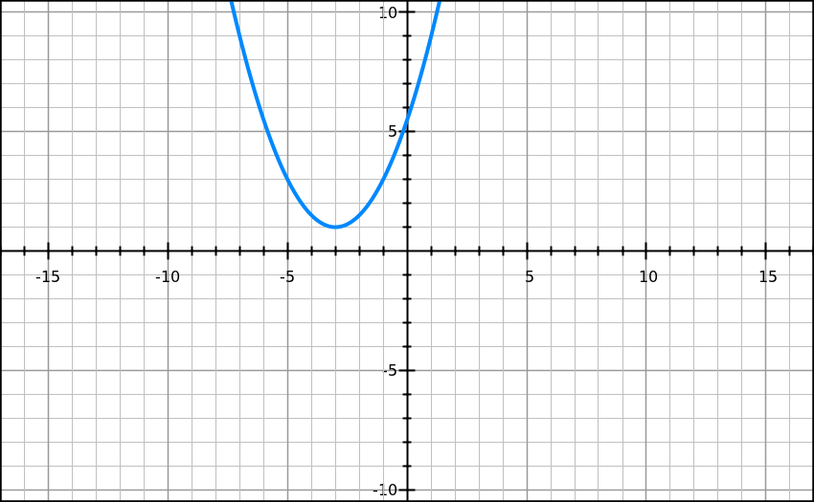

**18.** A flare was shot into the air with an upward velocity of 76 m/s. Its height, *h* metres, after *t* seconds is modelled by the equation y = 200 + 76t – 16t2. Give your answers to the nearest tenth, if necessary.

a) After how many seconds did the ball reach its maximum height?

b) What was the ball’s maximum height?

**19.** A rectangular playground is to be enclosed by a fence and divided into three sections with fencing parallel to two of its sides as shown. If 1200m of fence are used to enclose a maximum area,

**algebraically determine** the overall dimensions of the playground?

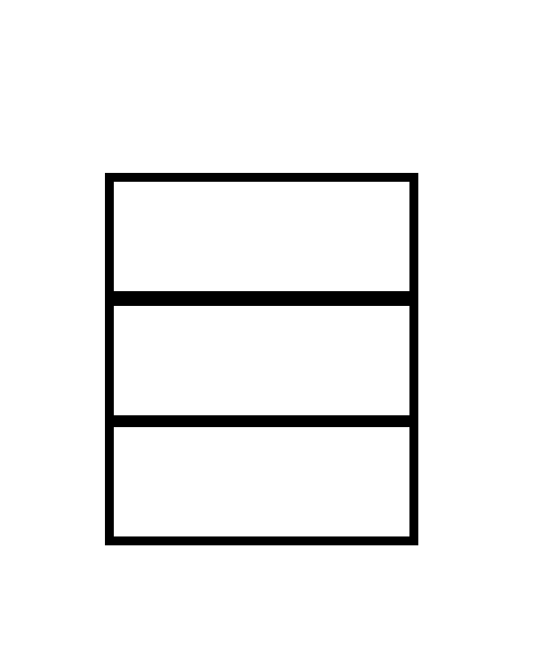

**20.** McDonald’s sells a cheeseburger for $1.49. At this price, they sell approximately 3000 cheeseburgers per day. Research indicates that for every $0.05 increase in price, the store will sell 50 fewer cheeseburgers. Determine the price of a cheeseburger that will maximize the revenue. (Use your graphing calculator to calculate your answer).

**21.** For what values of *k* does the equation x2 + 23x + k = 0 have two roots?

**22.** Find the *x*-intercepts of the quadratic function *y* = 2x2 + 63x - 300. Express your answers as exact values.

**23.** Circle the error in this solution of completing the square. Write the correct solution.



**Unit 1 Quadratic Functions and Equations Final Exam Review Key**

1. roots or x – intercepts
2. – 167
3. -0.41 and 4.91
4. 20 m
5. discriminant = 0
6. translated 5 units up
7. translated 15 units right
8. C
9. y = 4x2 – 72x + 322
10. 2x2 + 48x – 2449 = 0
11. 1808.04 m
12. 
13. 
14. y = -3(x – 3)2 + 49

17. 

18. a) 2.375 sec

b) 290.25 m

19. w = 150 m ; L = 300 m

20. $2.25

21. k > 132.25

22. 

23. Error in row 2. 9x should be 6x

y = 3 (x + 3)2 - 34