**Unit 2 Math 20-1 Ch.2 Radicals Final Exam Review**

**Written Response**

*Calculate the answers to these questions on a separate sheet of paper.*

**1.**Express  in simplified form.

1. Write this mixed radical as an entire radical: 
2. Write this entire radical as a mixed radical: 
3. Simplify.
4. Simplify the expression 
5. Express  in simplest form.
6. Expand and simplify this expression:
7. Expand and simplify this expression: 
8. Expand and simplify this expression: 
9. Rationalize the denominator: 
10. Simplify this expression: 
11. Simplify this expression: 
12. A square with area 54 square units is placed beside a square with area 75 square units.Find the outside perimeter of the given shape, in fully simplified form.

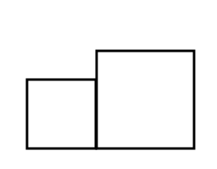

1. A square is inscribed in a circle. The area of the circle is . Determine the length of the diagonal of the square as an exact value. Determine the area of the circular portion not covered by the square.

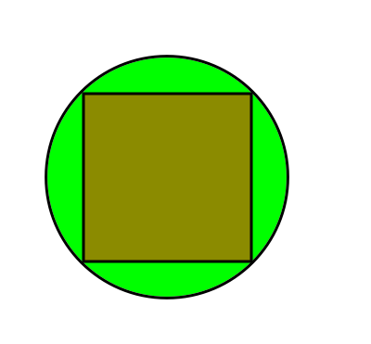

**16.** Write the expression in simplest form. Show your work.



**Math 20-1 Ch.2 Radicals Final Review Key**

1. 

3. 

4. 

5. 

6. 

7. 

8. 

9. 

10. 

11. 

12. 

13. 

14.

15. d=  and

16. 