**Unit 4 Math 20-1: Chapter 7 Absolute Value and Reciprocal Functions**

**1.** This is the graph of the absolute value of a linear function.

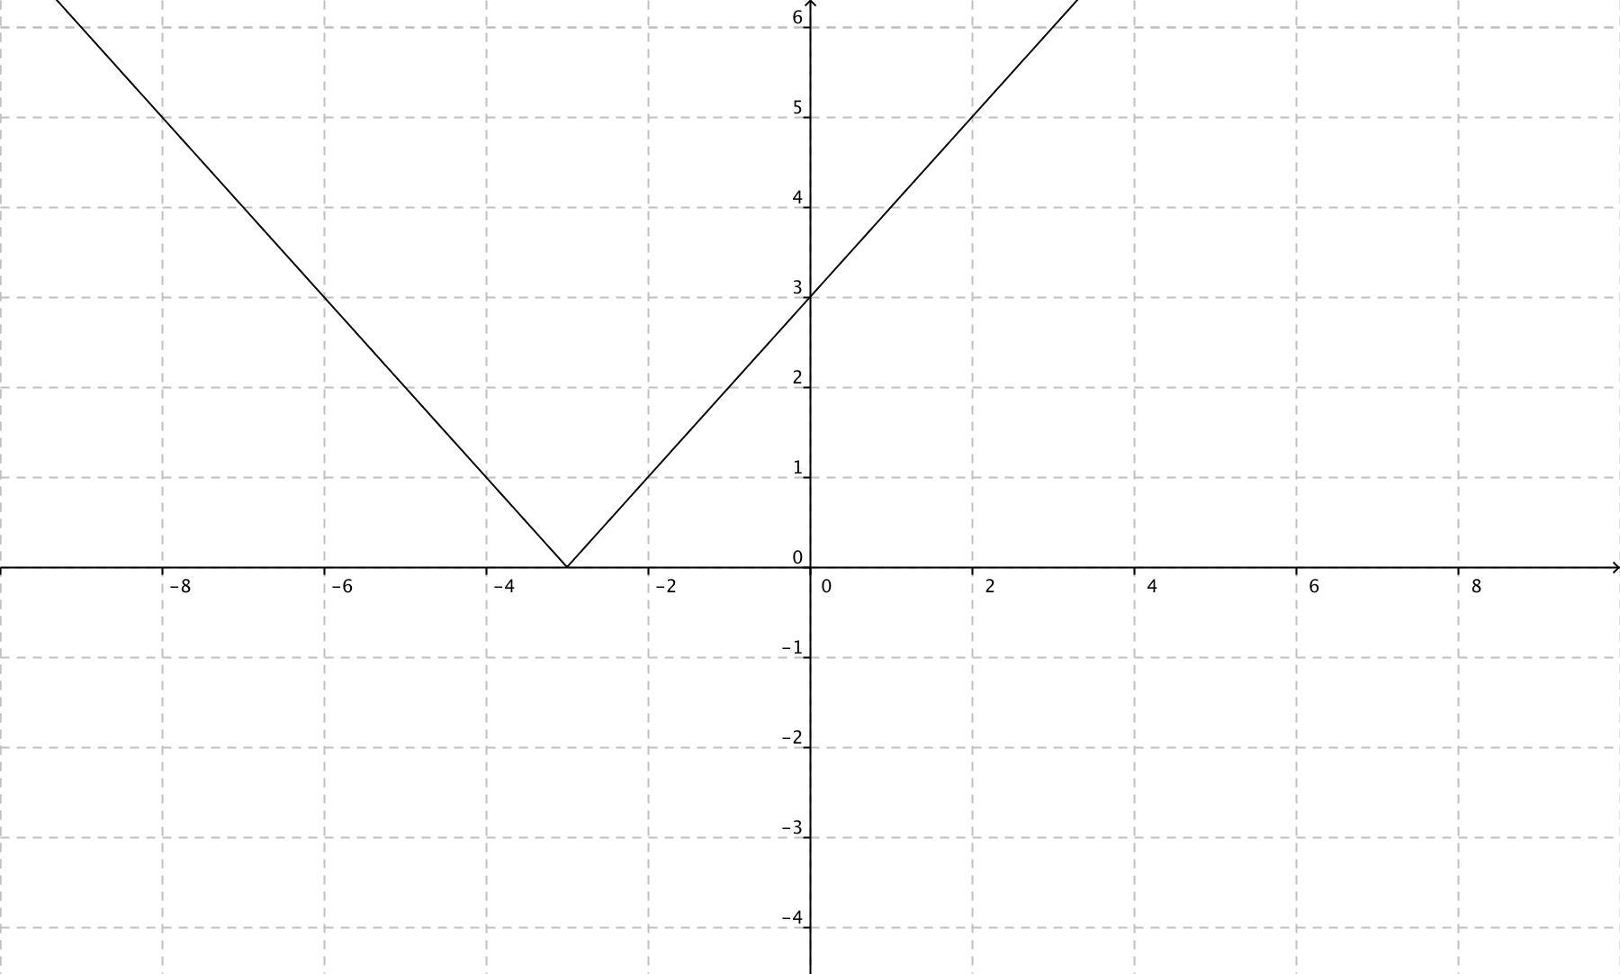

Draw the graph of the original linear function if the slope was positive .

**2.** This graph represents 

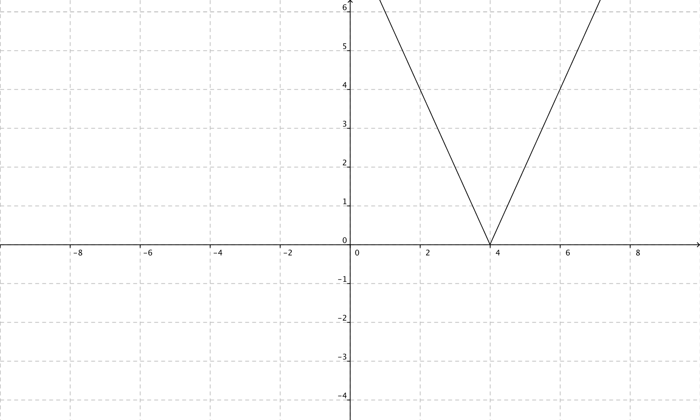

Write the function represented by the graph in piecewise notation.

**3.** This is the graph of the absolute value of a function *f*(*x*). What is a possible equation for *f*(*x*)?

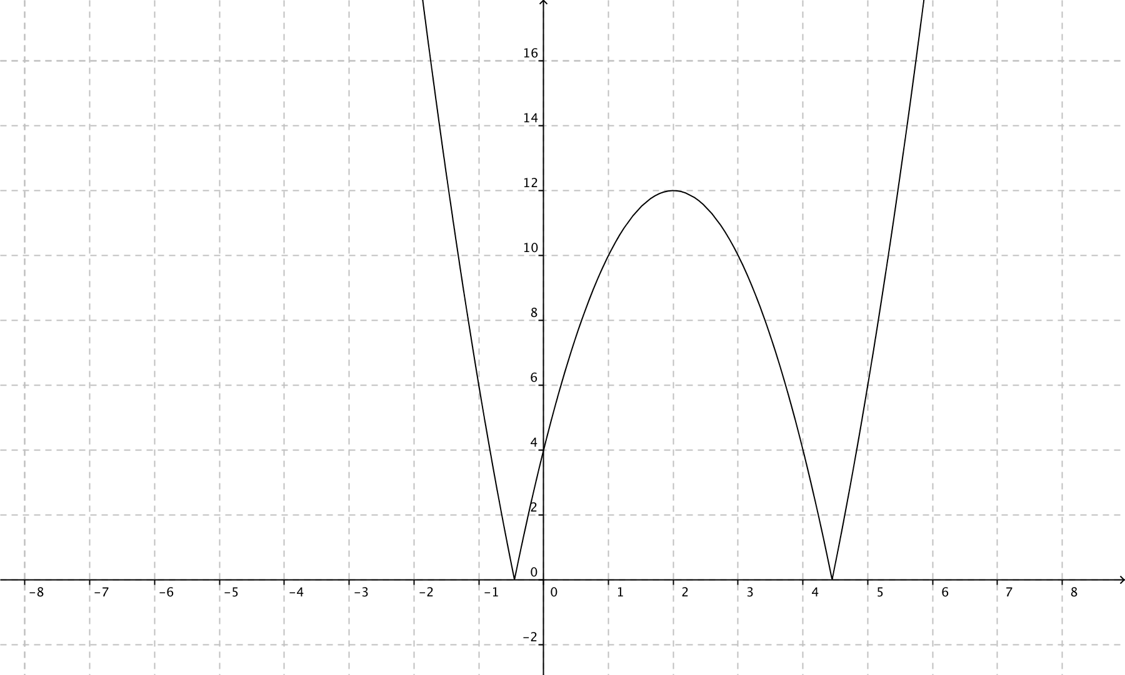

**4.** Solve this equation:  graphically. Round to the nearest hundredth.

**5.** How many solutions does the equation  have when y = 3?

**6.** For the function y = -7x + 6, write the equation of its reciprocal function.

**7.** This is the graph of a linear function. Sketch the graph of the reciprocal function?

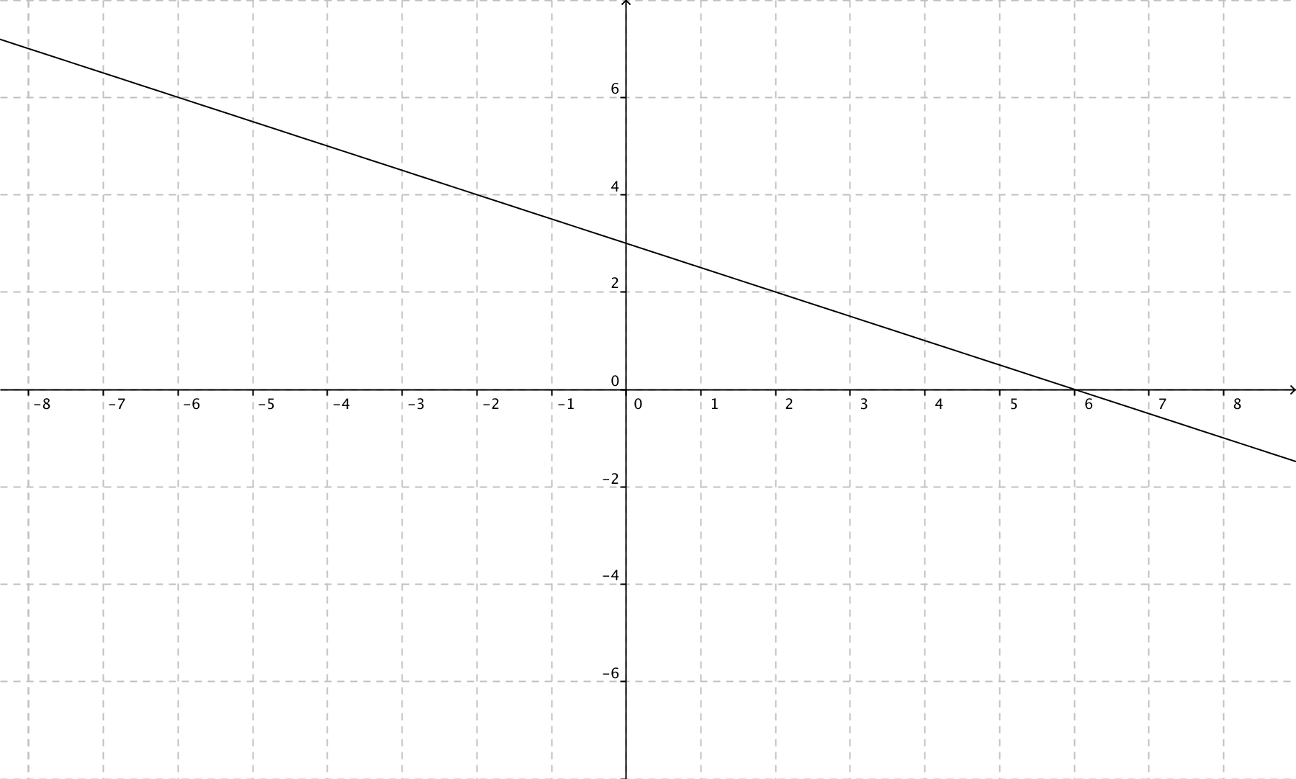

**8.** This is the graph of a linear function. What is the equation of the vertical asymptote of the graph of its reciprocal function?

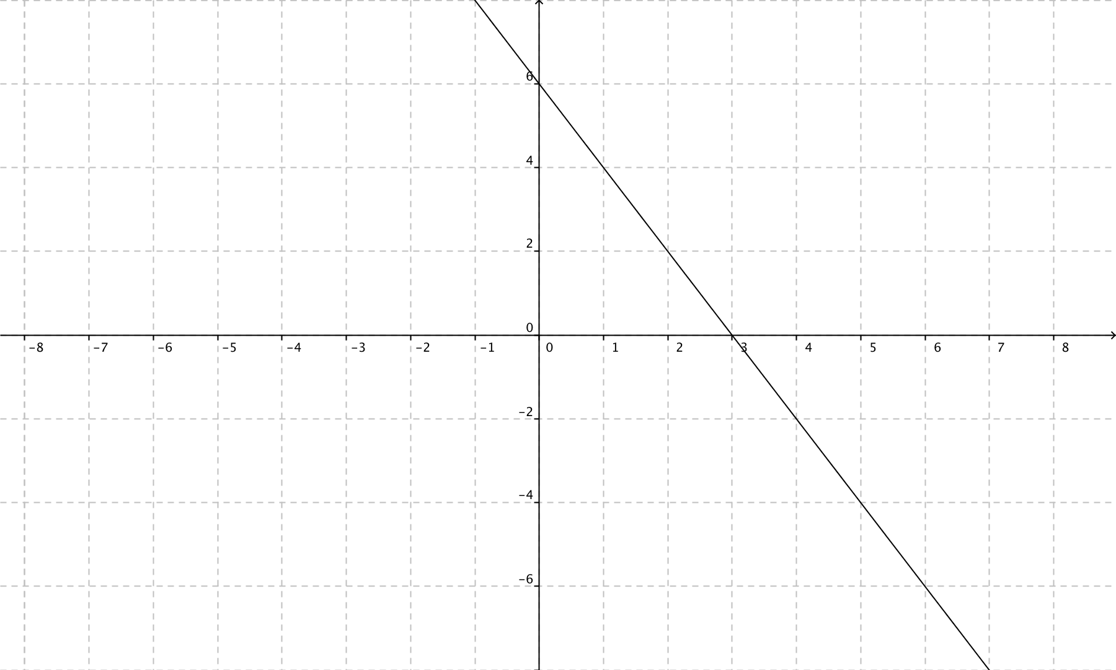

**9.** What are the domain and range of the reciprocal function?

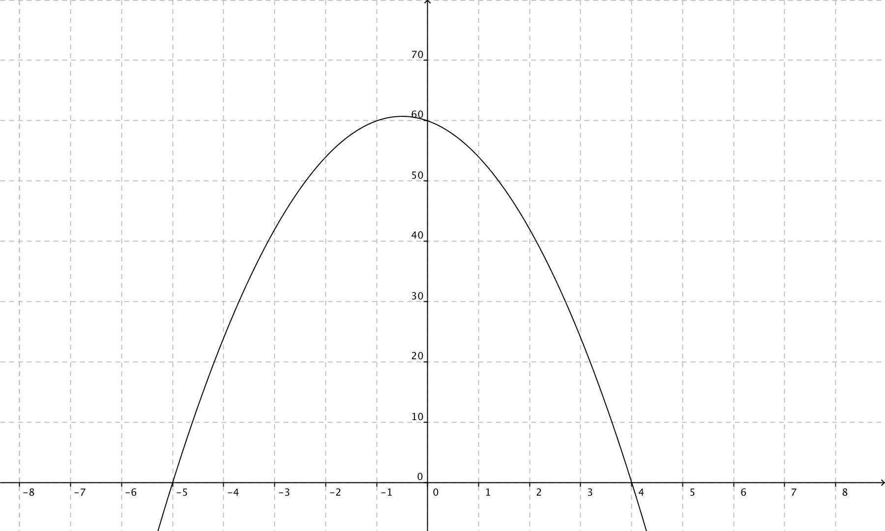

**10.** This is a graph of f(x). Identify the vertical asymptotes of the graph of the reciprocal function.

**11.** Here is the graph of *y* = . Sketch the graph of its reciprocal function?

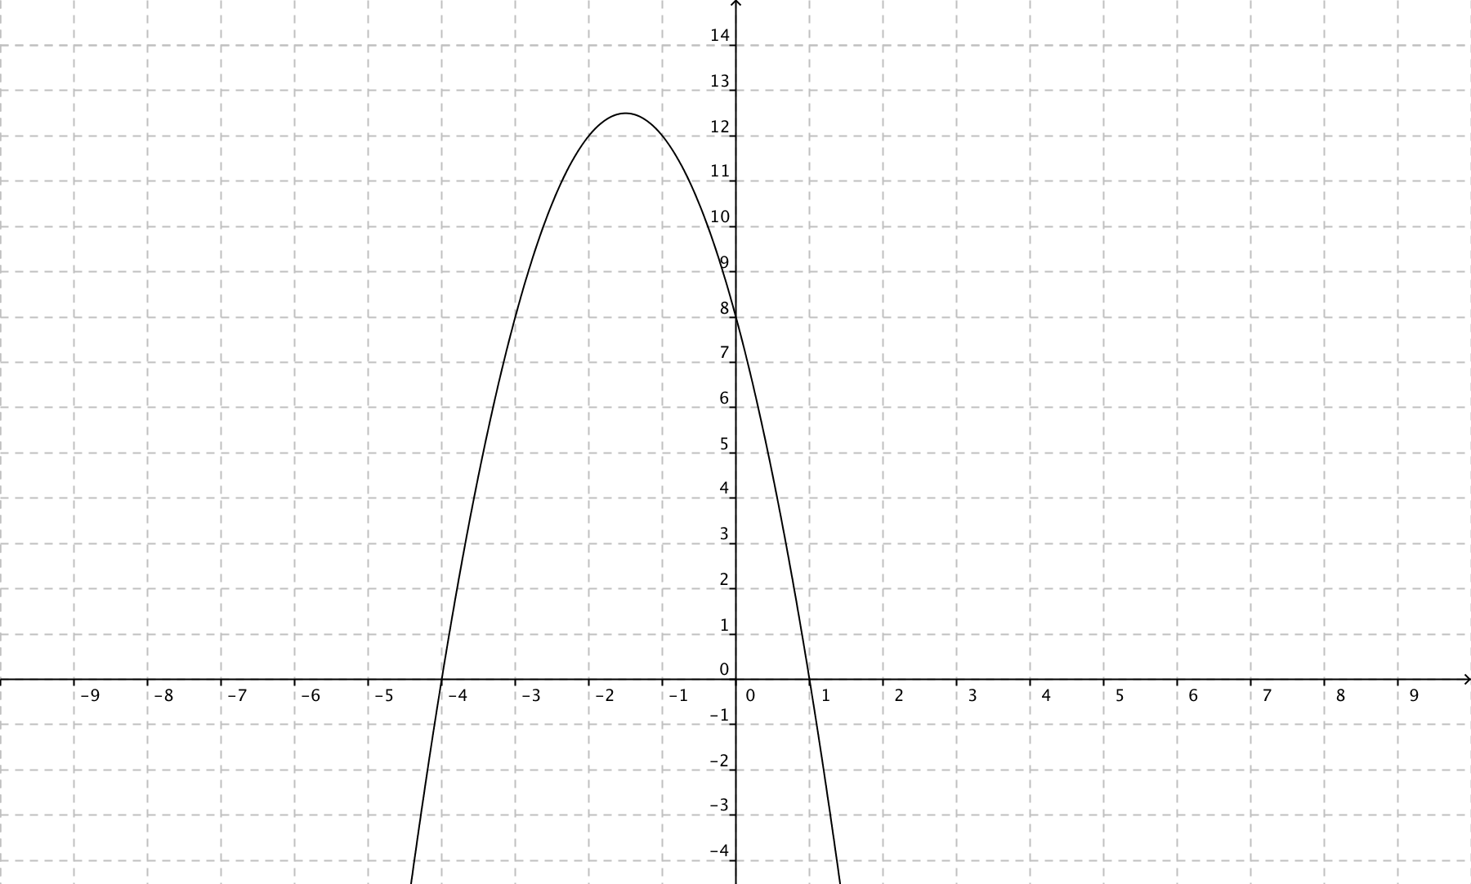

**12.** The result when  is evaluated is ___________________________.

**13.** The invariant points for the function  are___________________ and ________________.

**14.** Given the graph of :

**a)** sketch the graph of 

**b)** state the domain and range of the graph of the absolute value function.

**c)** express  as a piecewise function.

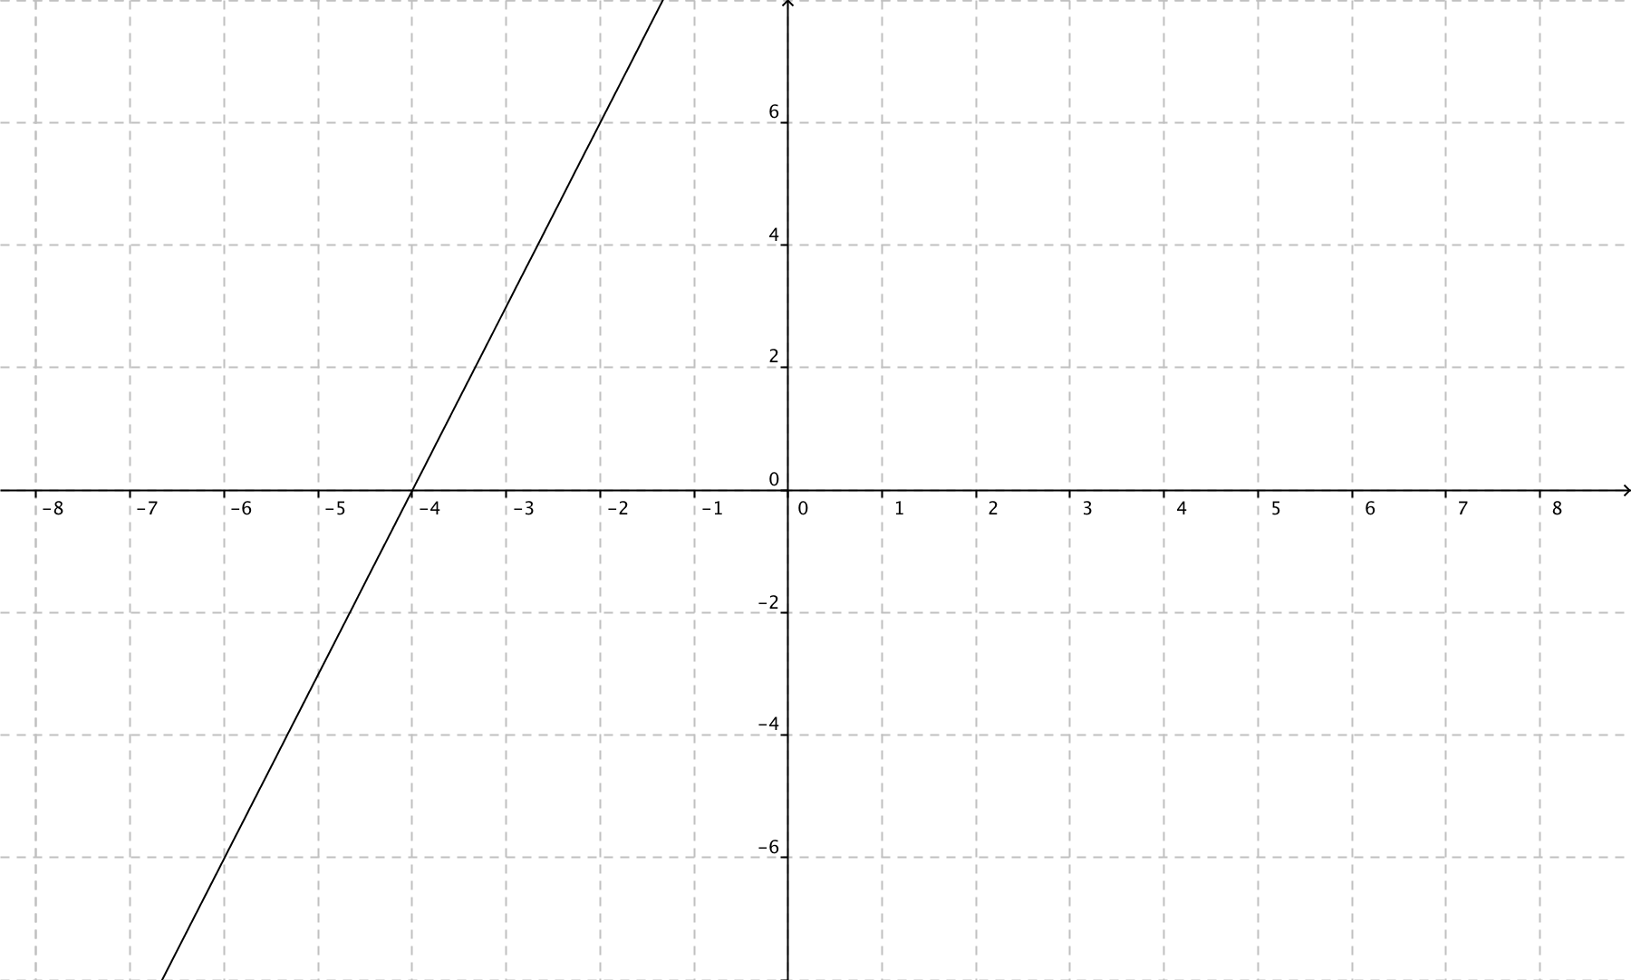

**15.** Determine the solution to .

**16.** Solve this equation: 

**17.** Solve the equation .

**18.** Solve .

**19.** This is the graph of a quadratic function *y* = . Sketch a graph of the reciprocal function  and identify the vertical asymptotes, if they exist.

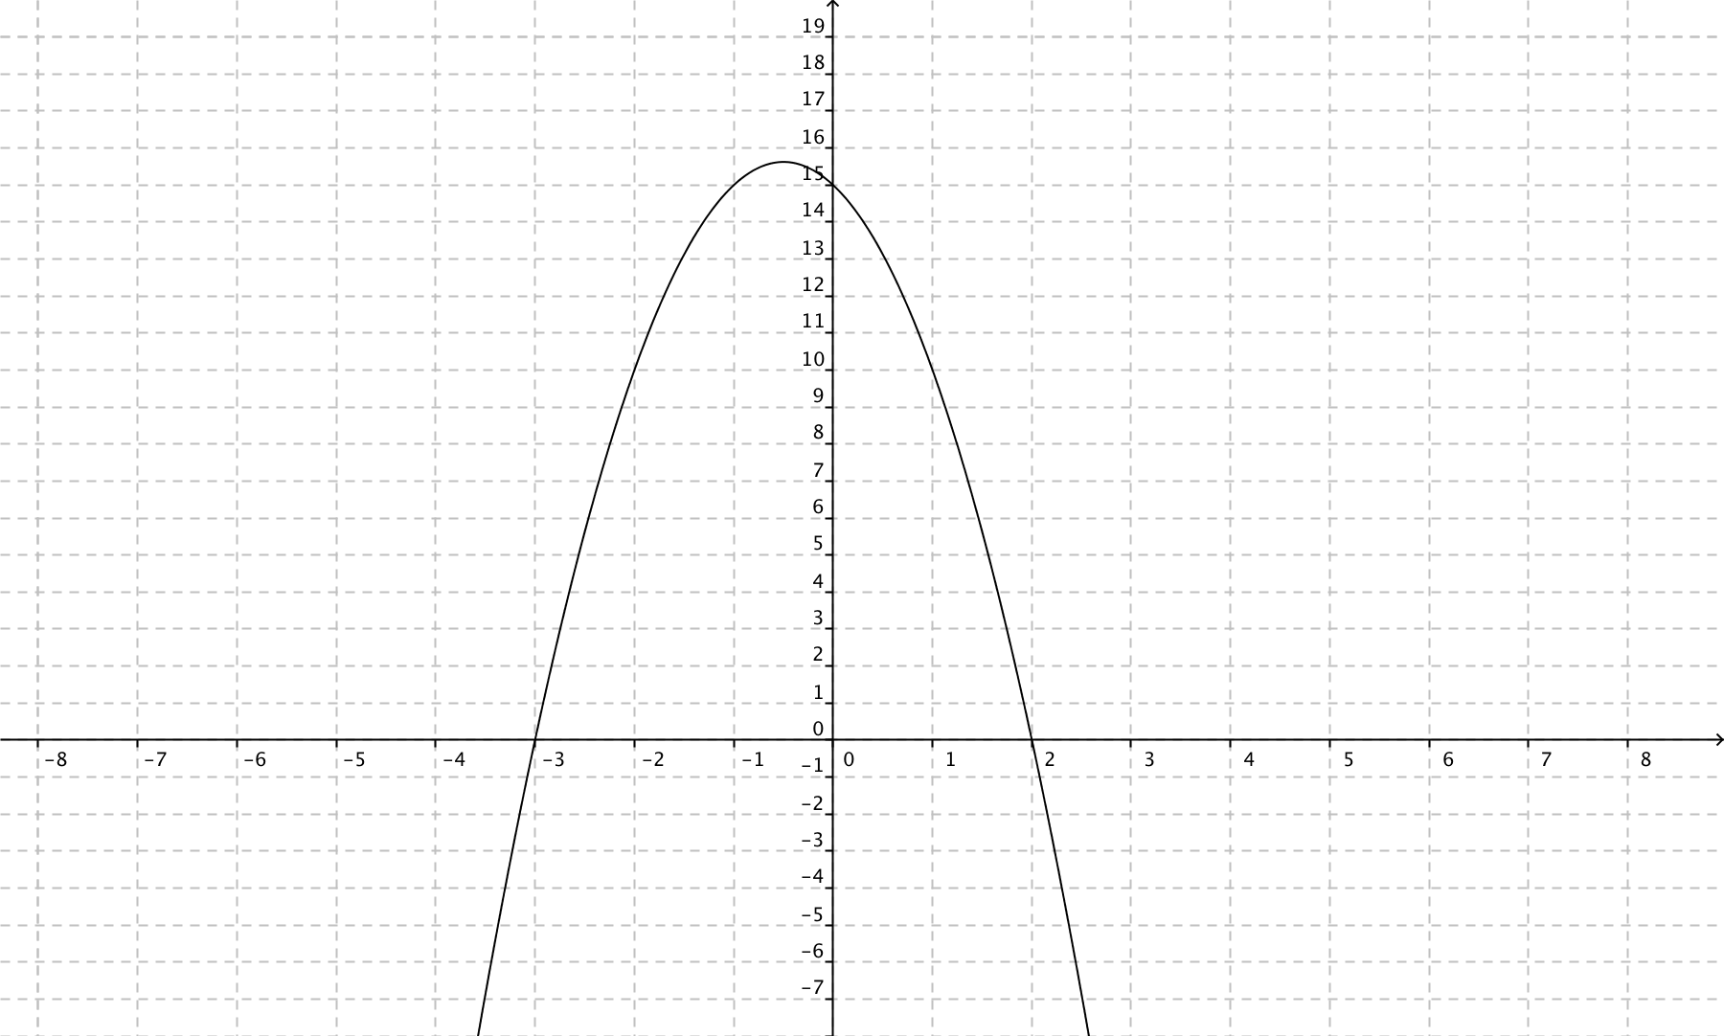

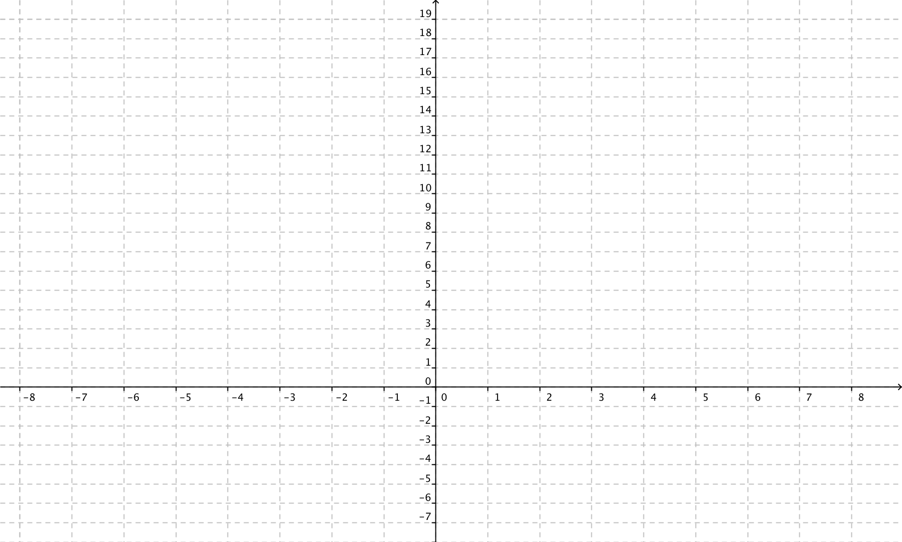

**Math 20-1: Chapter 7 Absolute Value and Reciprocal Functions Final Exam Review Key**

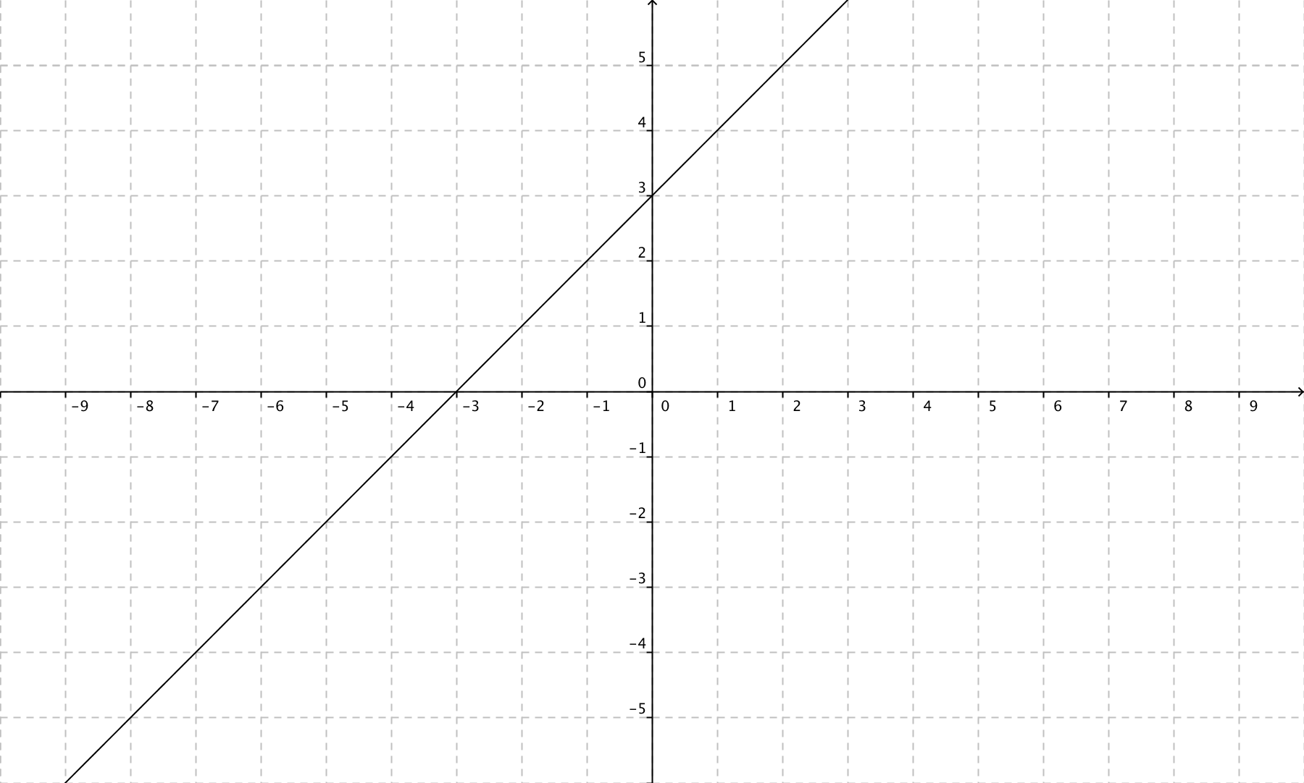**1.**

2. 

3. y = -2 (x – 2)2 + 12 or y = 2 (x – 2)2 - 12

4. (-2.35, 6) (2.35, 6)

5. 4 solutions

6. 

7.

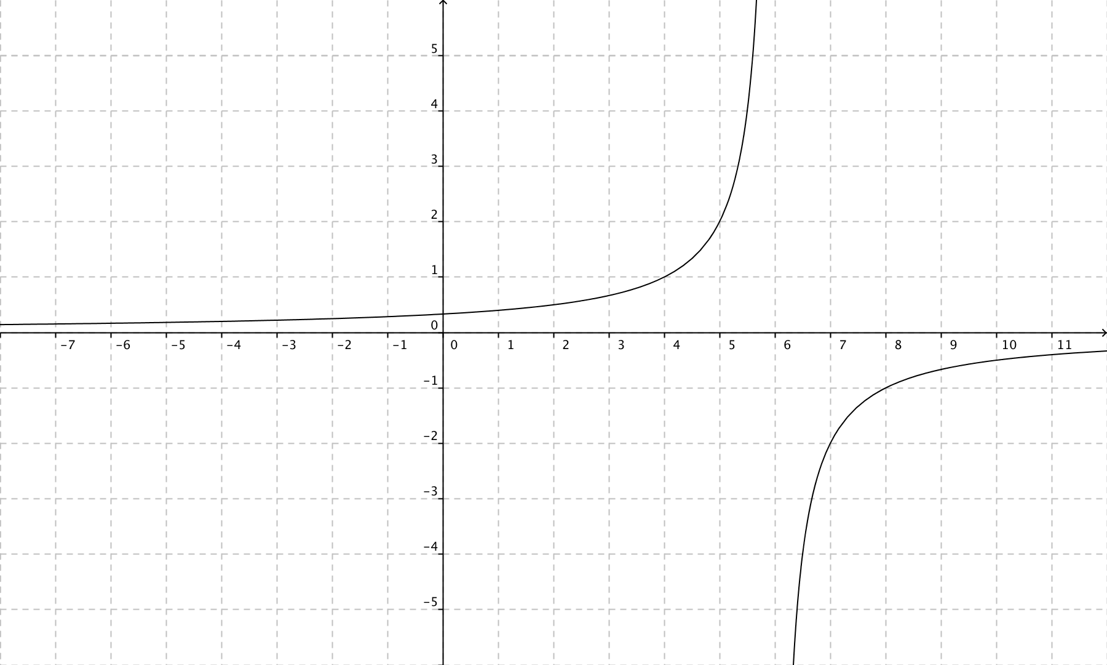

8. x = 3

9. D: 

10. x = -5 and x = 4

11.

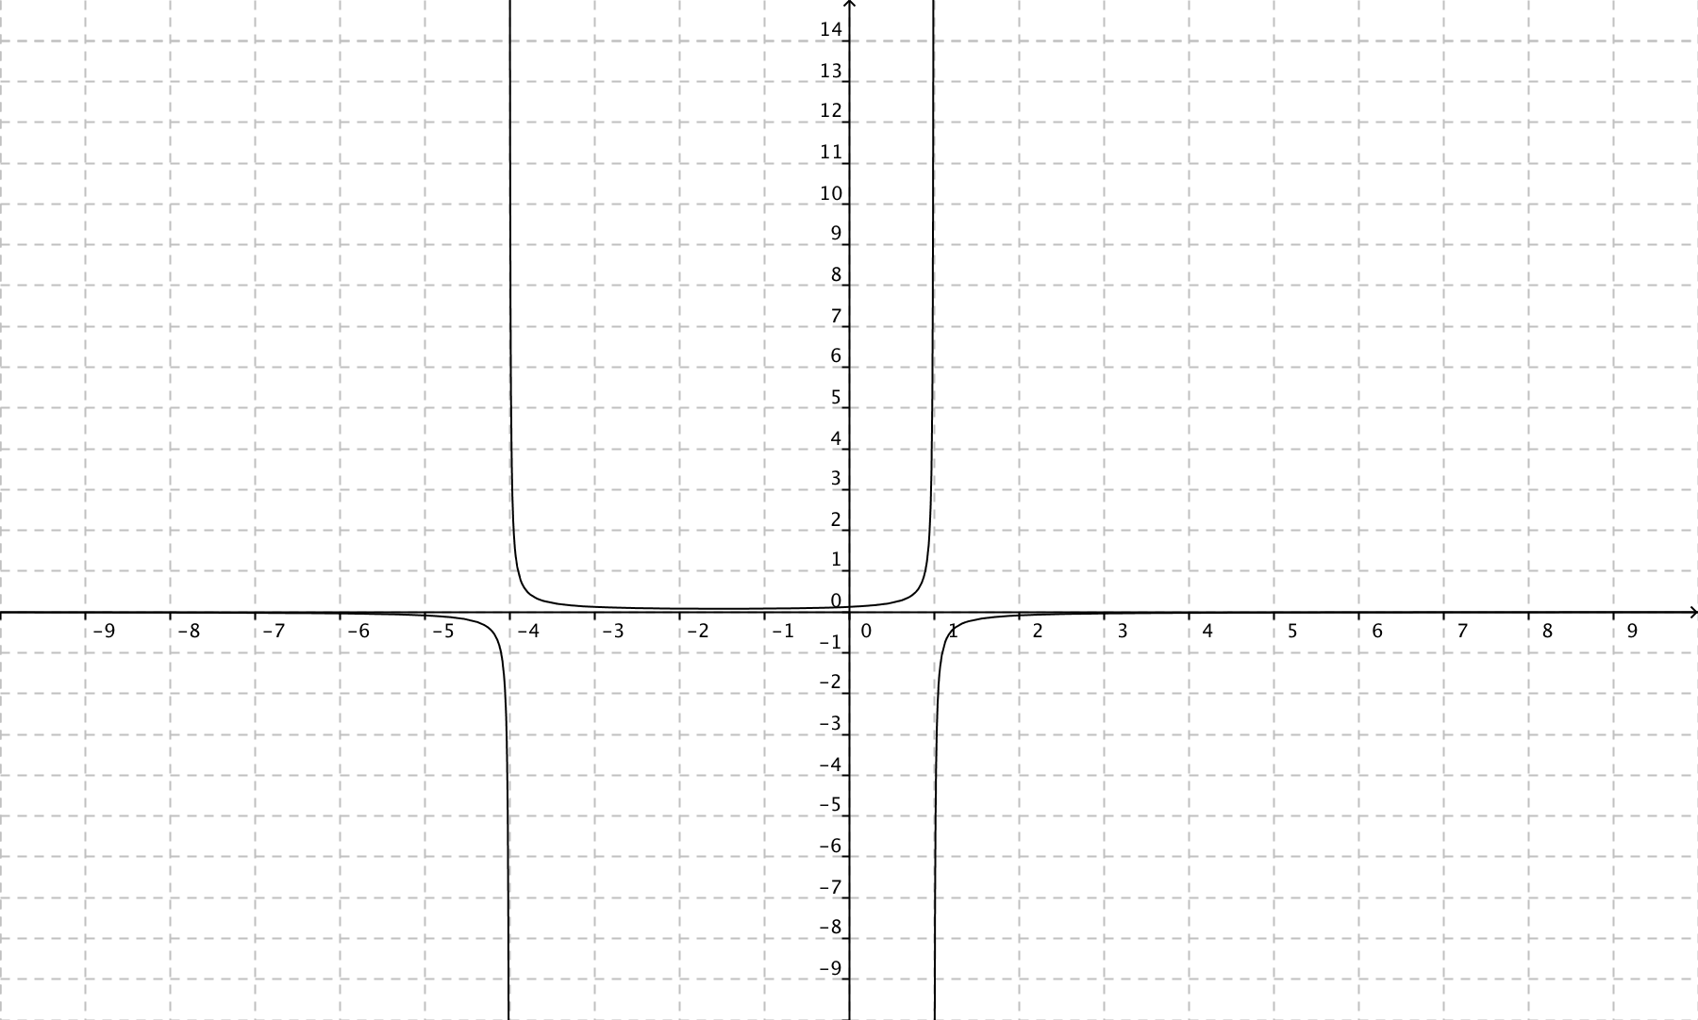

12. 391

13. (4.5, 1) and (3.5, -1)

14. a)

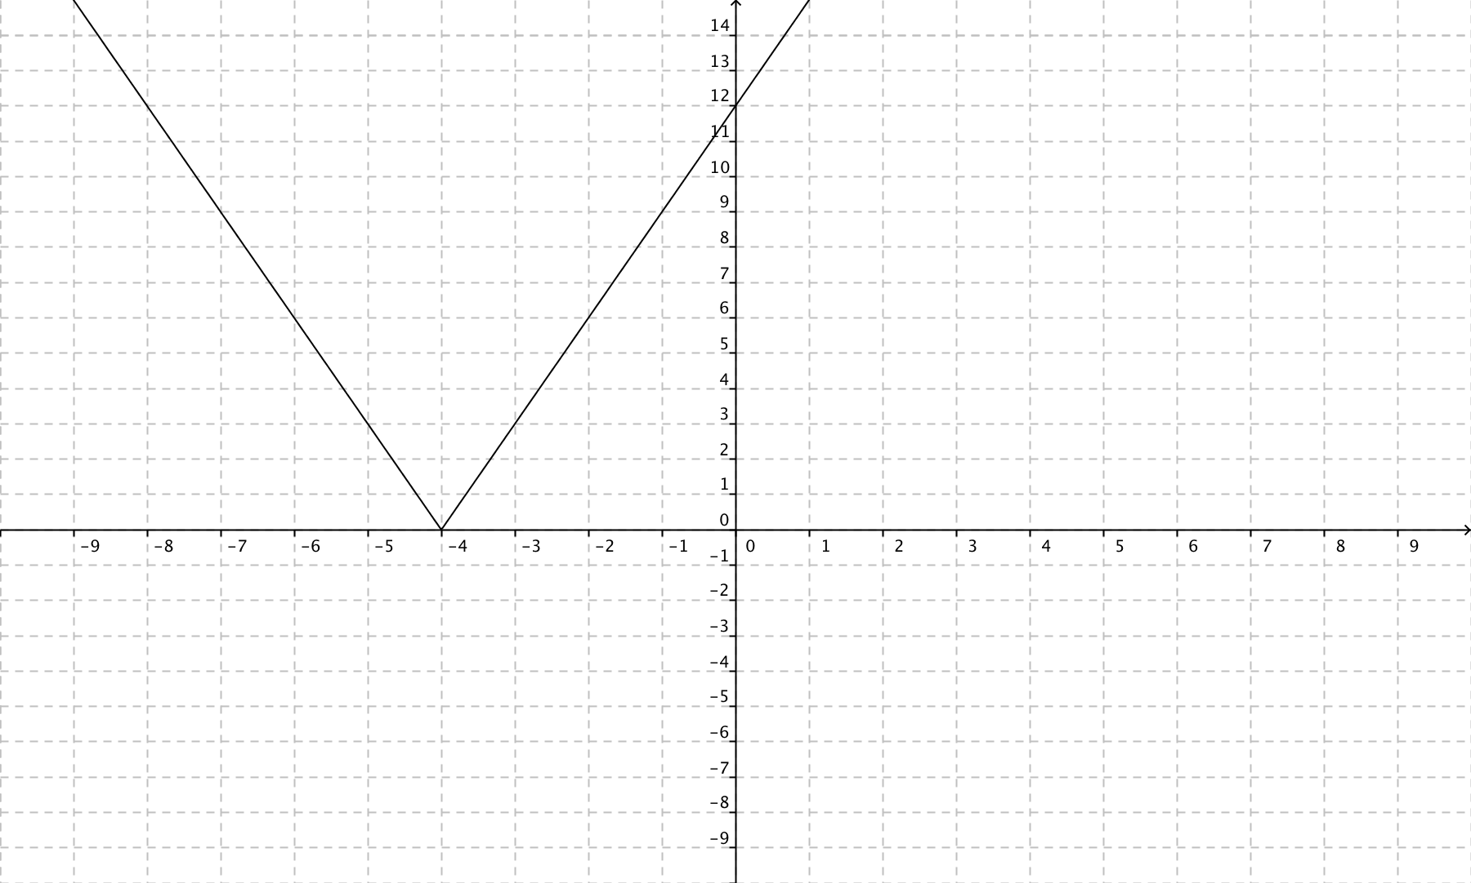

b) 

c) 

15. 

16. 

17. x = 3 and -3

18. and

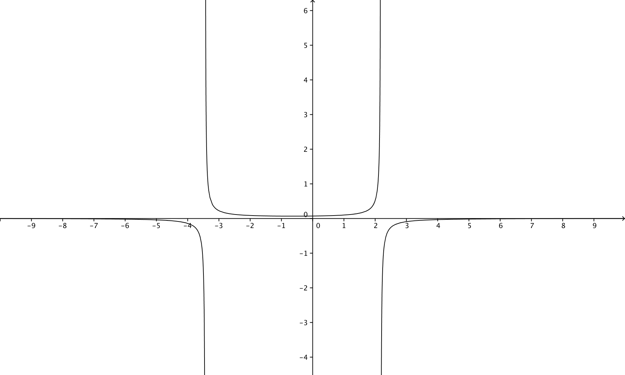

19.

1.