**Unit 5 Ch.8 Linear and Quadratic Systems of Equations and Inequalities**

**1.** Use the graph or a number line to write the solution of this quadratic inequality :

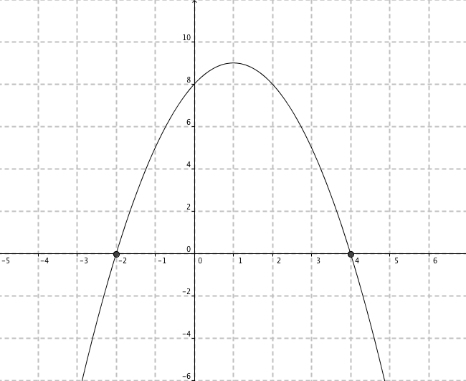

**2.** Which coordinates are a solution of the inequality 5x + 3y > 7?

|  |  |  |  |  |  |  |  |
| --- | --- | --- | --- | --- | --- | --- | --- |
| **A.** | (-2, -2) | **B.** | (1, -4) | **C.** | (2, 4) | **D.** | (2, -6) |

**3.** A massage therapist books patients for either 30-min or 60-min appointments. She sees patients a maximum of 40 h each week. Write an inequality that represents the massage therapist’s weekly appointments. Let *x* represent the number of 30-min appointments and *y* represent the number of 60-min appointments*.*

**4.** Which ordered pair is a solution of the quadratic inequality y > x2 - 4?

|  |  |  |  |  |  |  |  |
| --- | --- | --- | --- | --- | --- | --- | --- |
| **A.** | (-3, 2) | **B.** | (2, -3) | **C.** | (-4, 5) | **D.** | (1, 5) |

**5.** Which graph represents the inequality y > -0.5(x + 1)2 - 2? (no calculator

|  |  |  |  |
| --- | --- | --- | --- |
| **A.** |  | **C.** |  |
| **B.** |  | **D.** |  |

**6.** Use a graphing calculator to graph this system of equations.

Write the coordinates of the point of intersection to the nearest hundredth.

y = 2x2 - 8

-3.77x + 0.94y = -9.38

*A clothing store makes a profit of $50 on every pair of jeans sold and $25 on every blouse sold. The manager’s goal is to have a profit of at least $900 a day from the sales of these two items.*

**7.** If *x* represents the number of jeans sold and *y* represents the number of blouses sold, write an inequality that models the combinations of jeans and blouse sales that will meet or exceed the daily profit goal?

**Written Response: Calculate your answers on a separate sheet of paper. Show all of your work.**

**8.** Solve this quadratic inequality: 5x2 + 18x > 8 using test intervals.

**9.** For P(*p*, –4) to be a solution of 4x + 8y < 24 , what must be true about *p*?

**10.** a) Graph the inequality:y < (x – 3)2 - 2

b) Write the coordinates of a point that satisfy the inequality.

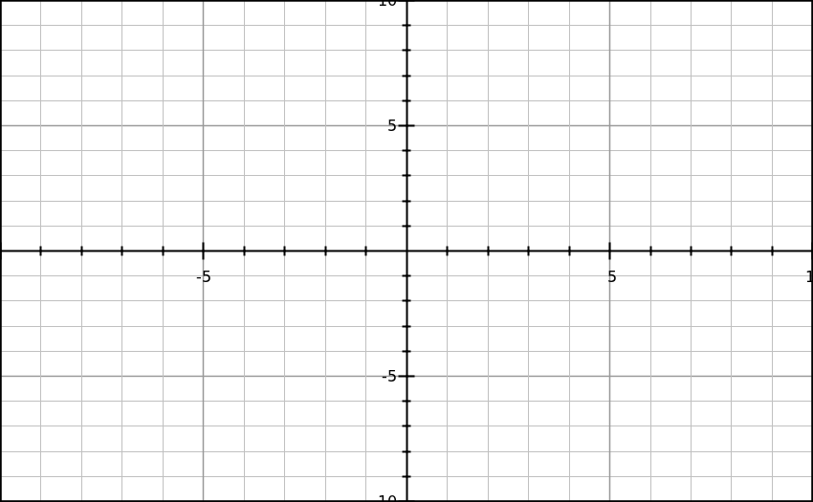

**11.** Write an inequality to describe this graph. (3 marks)

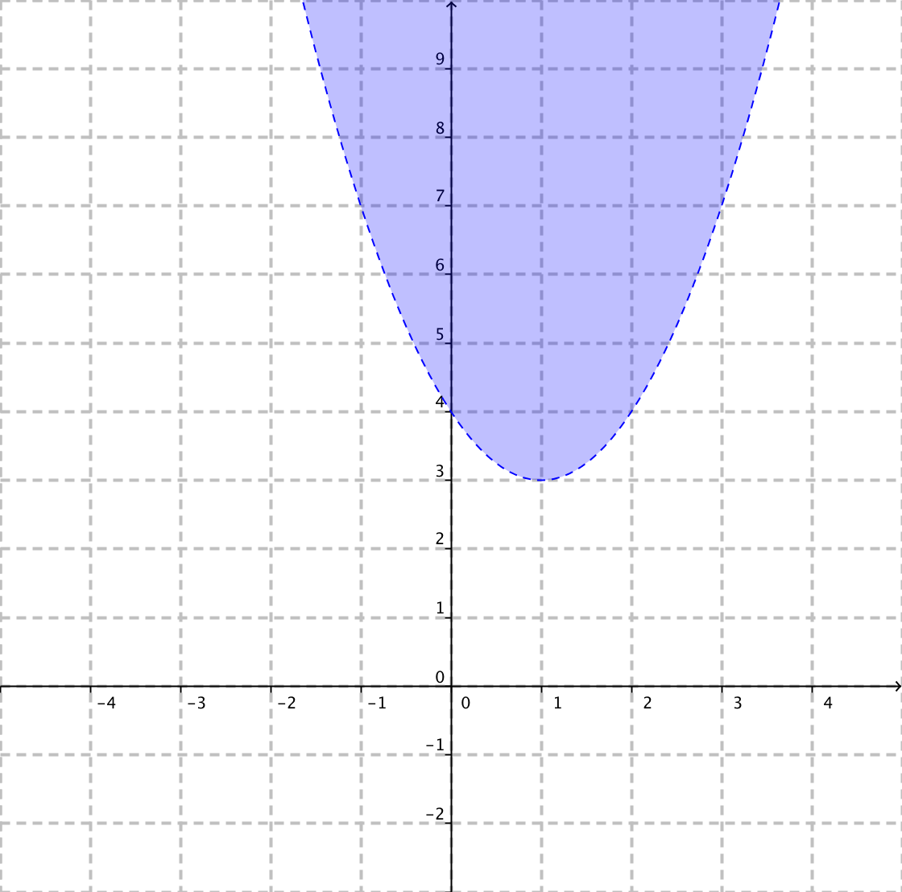

**12.** Solve this system algebraically

y = x2 + 3x – 49

y = 2x + 7

**13.**

**14.** Solve this quadratic-quadratic system algebraically.

y = 3x2 – 5

y = -4x2 + 1

**15.** Solve this quadratic-quadratic system algebraically.

y = (x – 3)2

y = -2x2 – 15x + 39

**16. Solve the following algebraically**. A toy rocket is fired and follows the path defined by

h = -16t2 + 177t + 4. A hot air balloon is travelling along the path defined by h = 80t + 150. Determine the coordinates of the point(s) when the toy rocket hits the balloon.

a) How many seconds after the rocket was fired did it hit the balloon?

b) How high above the ground was the rocket when it hit the balloon?

**17.** A men’s clothing store makes an average profit of $25 on each pair of shoes sold and $20 on each tie. The manager’s target is to make at least $600 a day on sales from shoes and ties.

**a)** What inequality represents the numbers of shoes and ties that can be sold each day to reach the target?

**b)** Graph the inequality.

**c)** If equal numbers of shoes and ties are sold, what is the minimum number needed to reach the target?



**Ch.8 Linear and Quadratic Systems of Equations and Inequalities**

**Final Exam Review Key**

1. 

2. (2, 4)

3. 

4. (1, 5)

5. B

6. (1.13, -5.45)

7. 

8. 

9. p < 14

10. a)

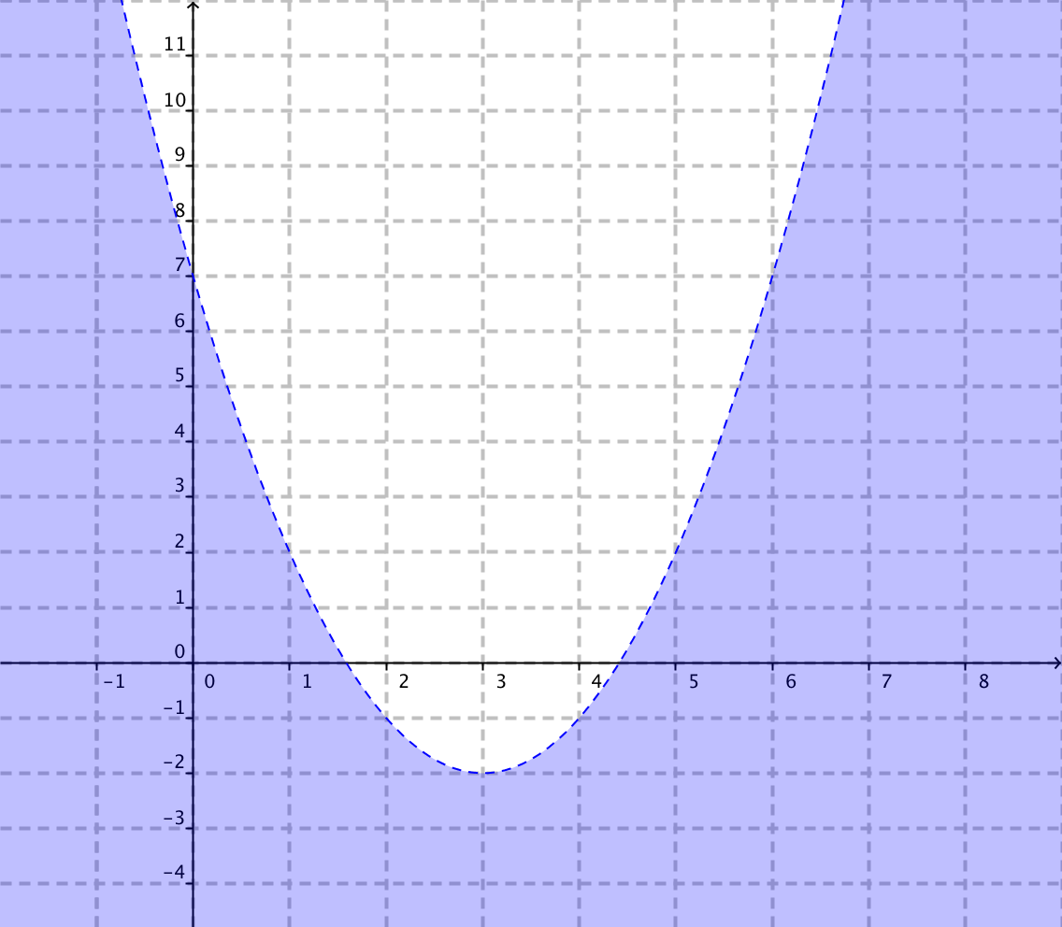

b) (0, 0)

11. y > (x – 1)2 + 3

12. (-8, -9) and (7, 21)

13.

14. (0.93, -2.43) and (-0.93, -2.43)

15. (-5, 64) and (2, 1)

16. (3.28, 412.4) and (2.77, 372.3)

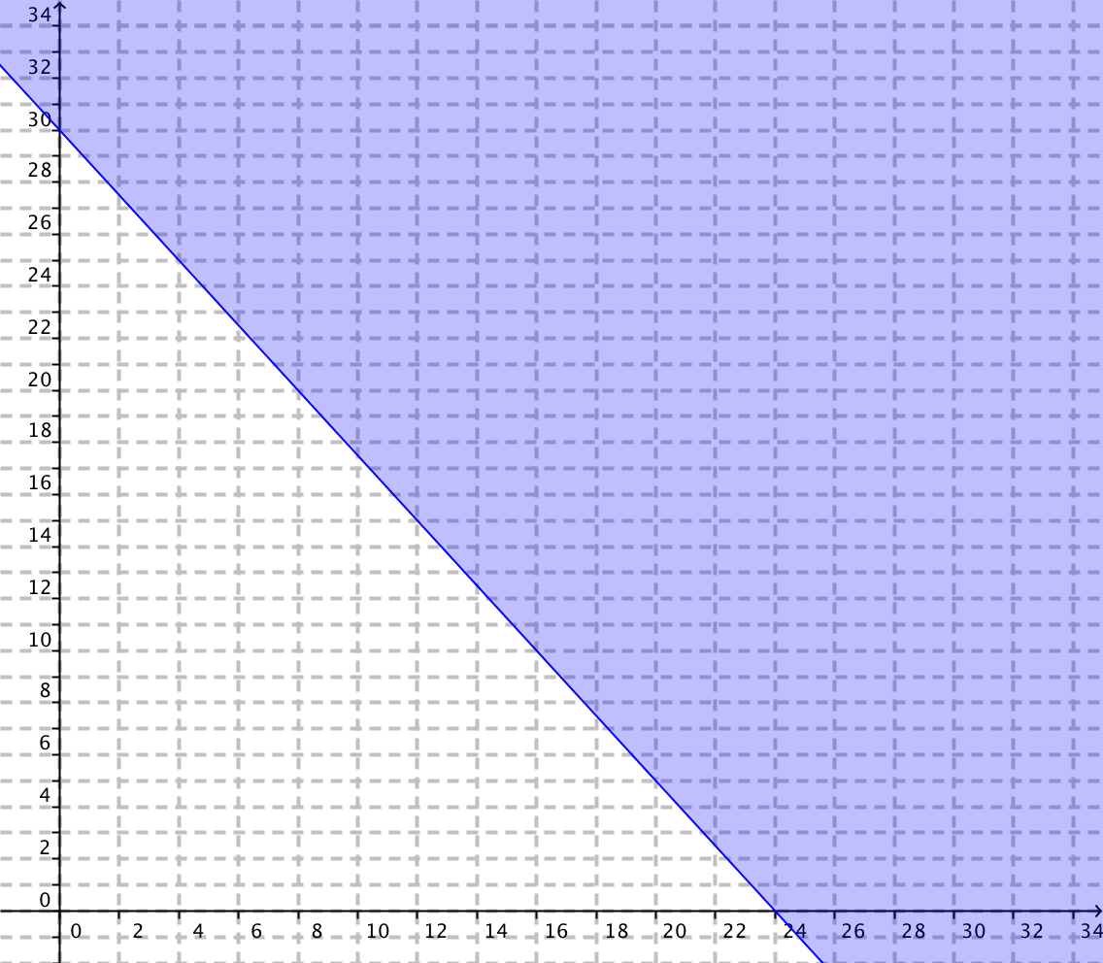

a) 3.28 sec

b) 412.4 m

17. a)  b) graph to the right

c) 14 of each