**Unit 7 Math 20 – 1 Ch.3 Trigonometry Final Exam Review**

**1.** Point P(-2, -7) is on the terminal arm of an angle ** in standard position. Determine the measure of ** to the nearest degree.

**2.** A guy wire is attached to a tower at a point that is 12 m above the ground. The angle between the wire and the level ground is 63. To the nearest tenth of a metre, how far from the base of the tower is the wire anchored to the ground?

**3.** An angle *θ* has its terminal arm in Quadrant 4. Which primary trigonometric ratio is greater than 0?

**4.** In which quadrant does the terminal arm of 177o angle in standard position lie?

**5.** Determine the reference angle for the angle 234° in standard position.

**6.** Determine the exact values of *θ* where  for $cosθ=\frac{-\sqrt{2}}{\begin{aligned}2 \\ \end{aligned}}$

**7.** Determine the exact value of cos 330.

**8.** Determine the exact value of tan 210.

**9.** Angle ** is in standard position and its terminal arm lies in Quadrant 2. The sine of its reference angle is $\frac{3}{8}$. Determine the exact value of $cosθ$

**10.** Determine the possible coordinates (*x*, *y*) of a terminal point for the angle 120° in standard position. The value of *r* is 7, where .

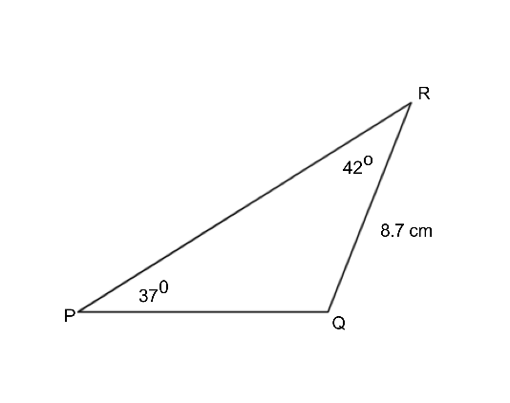**11.** For PQR, write the Sine Law equation you would use to determine the measure of side “q”.

**12.** What are the three other angles in standard position that have a reference angle of 67?

**13.** The point (15, –3) is on the terminal arm of A. Which is the set of exact primary trigonometric ratios for the angle?

**14.** An angle is in standard position such that $cosθ=\frac{2}{5}$. What are the possible values of , to the nearest degree, if ?

**15.** An angle between 0° and 360° that has the same sine value as sin 195° is ____________________.

**16. $P\left(\frac{-\sqrt{3}}{2}, \frac{1}{2}\right)$** and **Q $\left(\frac{\sqrt{2}}{2},\frac{-\sqrt{2}}{2}\right)$** are two points on theunit circle. If an object rotates counterclockwise from point P to point Q, the angle it rotates through is _______.

**17.** To the nearest degree, which values of *θ* satisfy this equation for ?

**19.** For JKL determine the length of KL to the nearest tenth of a centimetre.

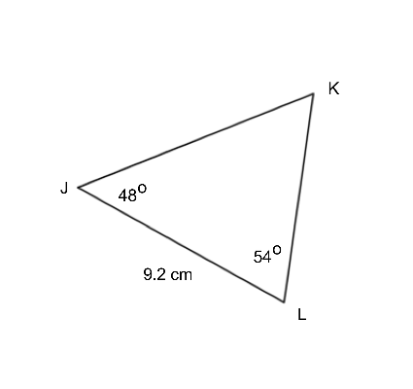

**20.** For ABC determine the length of AC to the nearest tenth of a centimetre.

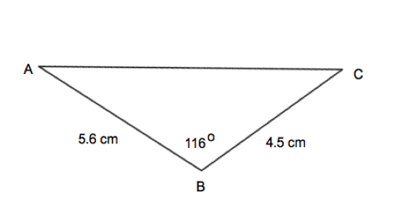

**21.** In ABC, B = 47°, AB = 4.1 cm, and BC = 5.8 cm. Determine the measure of C to the nearest degree.

**22.**  The following diagram represents a roof on a house. Determine the angle of the roof at <A. (2 marks)

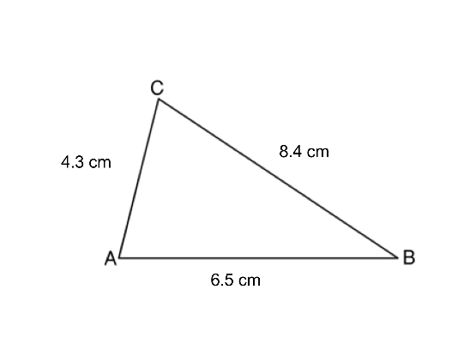

**Math 20 – 1 Ch.3 Trigonometry Final Exam Review Key**

1. 254o
2. 6.1 m
3. Cosine
4. Quadrant II
5. 54o
6. 135o and 225o
8. 113o, 247o, 293o
9. 66o, 294o
10. 345o
11. 165o
12. 215o, 325o
13. 6.99 cm
14. 8.6 cm
15. 45o
16. 100o