8- Factoring and Radical Equations Final Exam Review
- Factor x² + 5x - 24
- Factor 16f² – 81
- Factor 9x² - 30x + 25
- Factor 36(2x + 3)² – 49(y – 5)²
- What are the root(s) of $x=\sqrt{\text{13}x−\text{36}}$.
- What is the restriction on the following expression $\sqrt{2x−7}=1$
- Factor -5x² + 45x + 180
- Factor the following 64x² – 144y² completely
- Factor this polynomial 16(x + 3)² – 25(x - 6)² completely
- Factor the quadratic 4(x – 6)² + 40(x – 6) – 156 completely
- Solve by factoring 4x⁴ – 31x² – 45 = 0
- Solve $6+\sqrt{8+x^{2}}=x$
- Solve this equation: $−3\sqrt{x}−\text{27}\text{=-}\text{15}\sqrt{x}+5$
- Solve $\sqrt{x+4}=\sqrt{7x−6}$
- Solve $\sqrt{x+9}=\sqrt{2−x}+1$
- A rectangle has a length of 6x + 4 and a width of x - 3. If the area of the rectangle is 28 cm², determine the value of “x”.
- A rectangle, 4 cm longer than it is wide, has a diagonal that is $\sqrt{\text{250}}$ cm long. What are the dimensions of the rectangle?
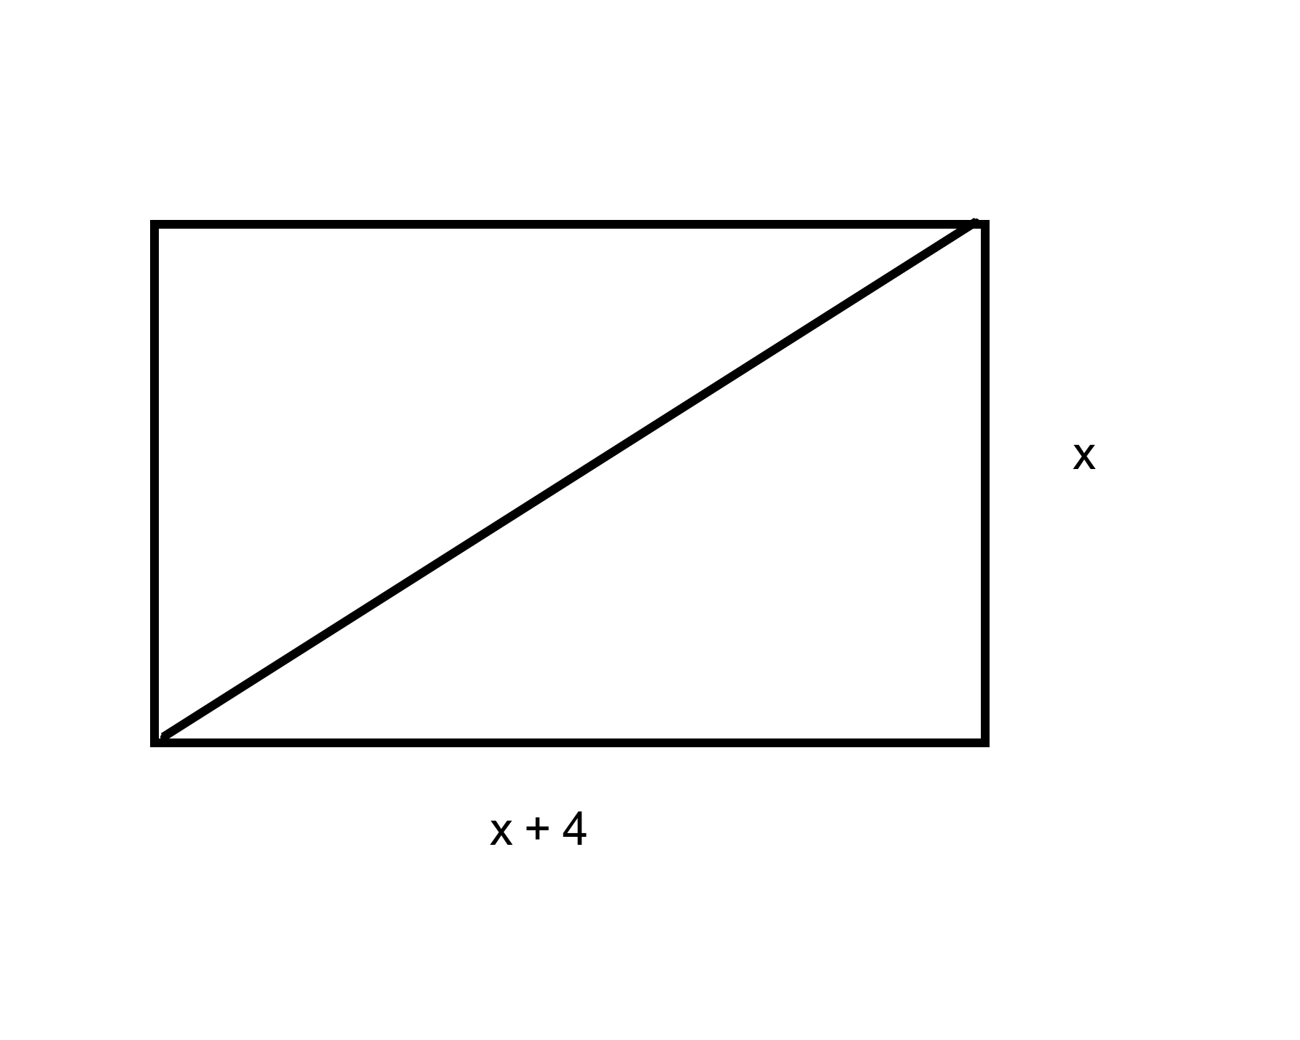

- The time, t in seconds, an object takes to reach the ground when dropped from h metres is given by the equation
$t=\sqrt{\frac{h}{4\text{.}9}}$ If an object takes 4 sec to reach the ground, from what height was it dropped?
Factoring and Radical Equations Final Exam Review Key
- (x + 8)(x - 3)
- (4f - 9)(4f + 9)
- (3x - 5)²
- (12x - 7y + 53)(12x + 7y - 17)
- x = 9 and x = 4
- $$x³\frac{7}{2}$$
- -5 (x – 12)(x + 3)
- 16 (2x – 3y)(2x + 3y)
- (-x + 42)(9x – 18)
- 4 (x + 7)(x – 9)
- x = 3 and -3
- $$x=\frac{7}{3}$$
- $$x=\frac{\text{64}}{9}$$
- $$x=\frac{5}{3}$$
- $$x=\frac{−7±\sqrt{\text{21}}}{2}$$
- $$x=4\text{and}\frac{−5}{3}$$
- 9cm by 13 cm
- 78.4 m

