Test Taking Strategies for Math

*Preparation:*

* Repetition is important in math. You learn how to solve problems by doing them, so practice problems.
* Do a little each day, or at the very least start studying 4-5 days before the exam.  Cramming the night before an exam is poor practice.
* Use quizzes and concept checks to inform you of strengths and weaknesses in a unit.
* Redoing problems you had trouble with when you went through the homework is the best place to start your studying.
* When practicing, try to solve the problem on your own first then look at the answer.
* When practicing always check your answers!
* If you find yourself struggling, reread your notes on the concept, read the textbook, ask a friend or go see your teacher.
* Take a practice exam online or from your textbook. Give yourself an appropriate time limit and treat it as you would an exam… No phone! No partners! Limited time!
* Predict test questions by referencing questions gone over in class with questions assigned with questions on quizzes or concept checks.
* Consider daily, weekly and unit reviews.
* Set realistic goals for your performance.

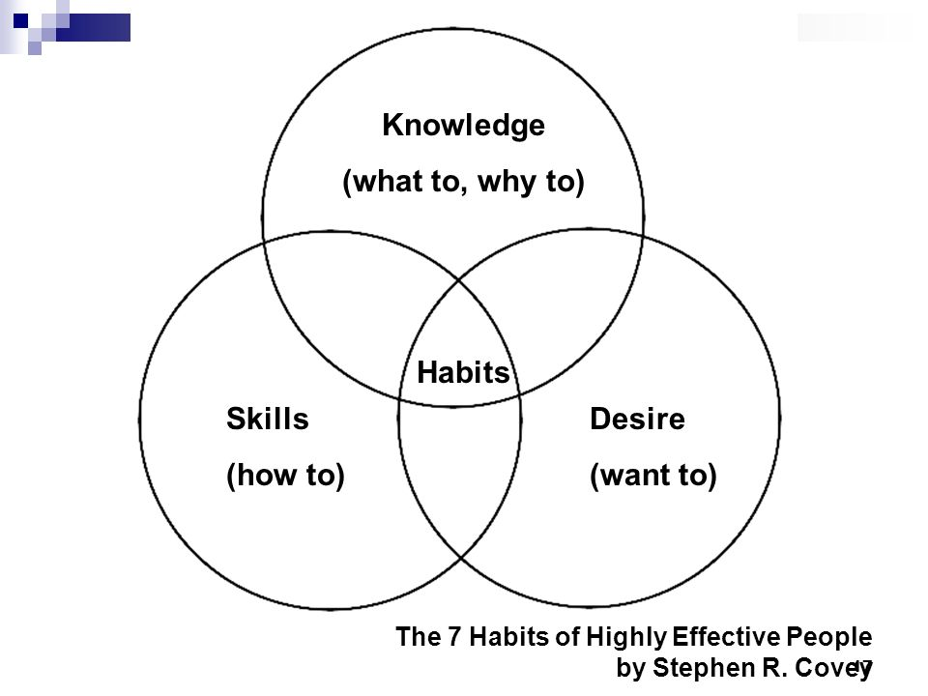

*Test Taking:*

* Don't Stress! If you took the time to study, you did everything you can. Be confident!
* Use pencil so you can make corrections neatly.
* Answer questions you know right away and spend your energy on problems you know you can do.
* If you find yourself taking too long on a problem, skip it and come back.
* **Recognize and eliminate the clearly wrong multiple choice answers.**
* **Take applicable shortcuts for multiple choice questions.**
* **Circle, highlight or underline key terms, or information.**
* Neatness makes it easier to recognize the next step in your solution and makes it easier to check your work
* If you don’t know the complete answer but remember some part of the solution, write it down. You may get partial credit if you are partly correct. Leaving a blank will get you nothing.
* Consider the amount of space provided as a possible clues to the length of your solution.
* Check your work (but only when you are done all the other questions on the exam!)
* Check your calculator entries (but only when you are done all the other questions on the exam!)

