**Math 10C Unit 7**

**Chapter 1 – Measurement**

**Name:____________________________**

**1.1 Referents and Systems**

**The Point**

* Learn about *Referents* and Imperial vs SI Measures.
* Measuring basic units in each system

**SI vs IMPERIAL**

Check your (or a friend’s) learners’ permit. What does it say for height?

Even though Canada adopted *La Système Internationale d'unités* in 1976, many people still use **Imperial Units** for things like height & weight.

|  |
| --- |
| *The focus in this lesson will be on the imperial system.* |

**DEFINITION**

Referent – A referent is something that may be compared when trying to   
 estimate a length.

ex. The width of a pinky finger is ~1cm.

The length of your foot is ~ 1 ft.

The length of a stride is ~1 meter or 1 yd.

**THE “OLD” WAYS**

1. In England, the **inch** has been in use since medieval times. In 1324, Edward II decreed that the inch was the length of 3 barley corns placed end-to-end.
2. The **foot**, a length of the human foot, was anything from 9 3/4 to 19 inches.
3. Henry I (1100-1135) decreed the lawful **yard** to be the distance between the tip of his nose and the end of his thumb.
4. In the past every part of England had its own **mile.**

|  |
| --- |
| *Do Do you see any problems with the “ancient" measuring system?* |

**THE IMPERIAL SYSTEM**

The inch, foot, yard, and mile are the typical units for imperial length. Fractions are used instead of decimals. (ie. 5/8 of an inch)

**12 inches = 1 foot 3 ft. = 1 yard 1760 yd. = 1 mile**

|  |
| --- |
| Feet and inches get special symbols:    An easy way to remember is by counting the syllables. Inches has two, Feet has one. |

**ESIMATING INCHES**

You need a ruler. Measure a true inch here:

Determine a referent for 1 inch.

**MEASURING INCHES**

Measuring inches requires the use of fractions. Most rulers have a similar number of “ticks” per inch that become the denominator.

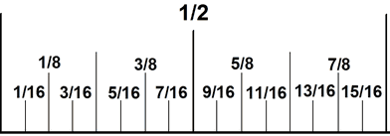

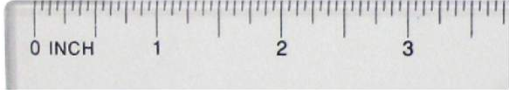

(not to scale)

|  |
| --- |
| *Why will you not see  as the final answer for a measurement?* |

**MEASURING YOURSELF**

Measure the longest length in inches, with a ruler:

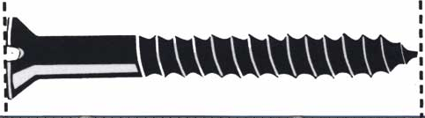

LENGTH:

**PRACTICE**

Mark on the ruler below:

a)  b)  inch

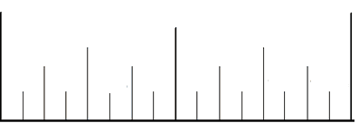 

c)  d) 

 

Measure with a true ruler:

e) 1  inch f) 

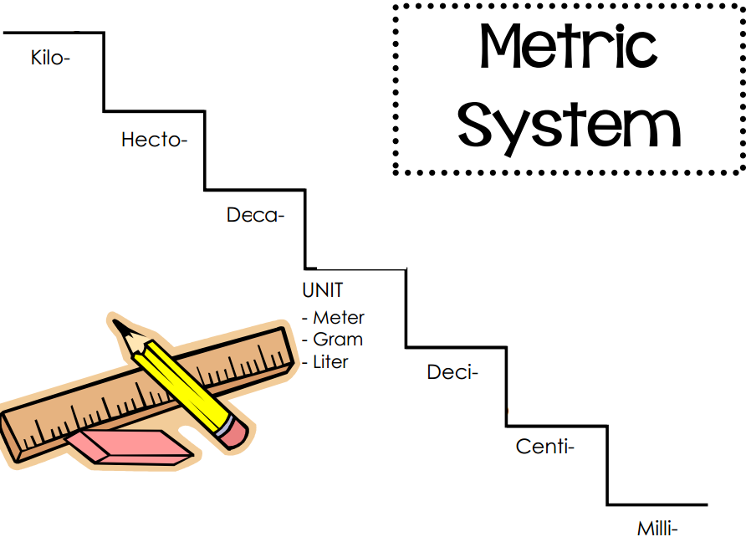

**METRIC REFERENT**

Using a ruler, measure 1 cm:

What is a good referent for 1 cm?

**MEASURING IN METRIC (SI)**

Indicate the following lengths on the metric ruler:

1. 1.2cm



1. 35mm



1. 7.7cm



**EXAMPLE 1**

With a ruler, determine the actual length of the screw. Was your estimation close?



Actual length in cm: ____________

**EXAMPLE 2**

Determine the width of two desks pushed together. Is cm still the best measure? Is a ruler the best device?

**EXAMPLE 3**

Determine the approximate width of the classroom. How can we estimate this? How can we measure this?

**ASSIGNMENT**

1. Using your ruler measure the following lines.

**METRIC IMPERIAL**

a. ______________________________________________ ___________ ___________

b. __ ___________ ___________

c. ____________________ ___________ ___________

d. ________________________________ ___________ ___________

1. Mark on the rulers below the indicated length:

a)  b)  inch

 

1. Read the rulers below:
2. b)

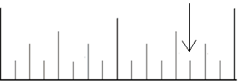 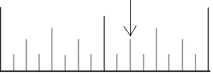

1. Write your estimate and actual length of each object in the following list. You may choose to use metric or imperial

|  |  |  |
| --- | --- | --- |
| **OBJECT** | **ESTIMATION** | **ACTUAL LENGTH** |
| Width of this booklet | inches | inches |
| Diameter of a circle | cm | cm |
| Height of the soup can below | inches | inches |
| Length of left penguin’s beak | inches | inches |
| Height of a penguin | cm | cm |
| iphone 6 plus (diagonal) | inches | inches |





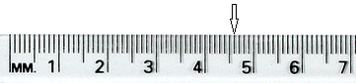

**1.3 Converting Units (part 1)**

**The Point**

* Converting Imperial and SI Measures.

**REMINDER**

List the metric measures, starting with km

|  |
| --- |
| **_____ _____ _____ _____ ____ _____ _____** |

**Convert the following:**

1. 3 000m into km b) 900 000cm into km
2. 20 mm into cm d) 3.7 cm into dm
3. 53 hm into dm e) 275 mm into m

**INVESTIGATE 1**

How many minutes is:

1. 0.5 hours b) 0.25 hours

|  |
| --- |
| ***Not all values are out of 10 or 100.***  *One hour is a total of 60 minutes. One foot is a total of 12 inches. One yard is a total of 3 feet.* |

c) 0.75 hours d) 0.2 hours

**REMINDER**

Solve the following equations below by cross-multiplying.

*(move diagonally to the x by itself)*

$$\frac{5}{3}=\frac{x}{6}$$

**INVESTIGATE 2**

Can you determine how many INCHES the following feet are?

1. 0.5 feet b) 0.25 feet

|  |
| --- |
| *You can always cross-multiply to convert units* |



c) 0.75 feet d)  feet (what is the equivalent fraction?)

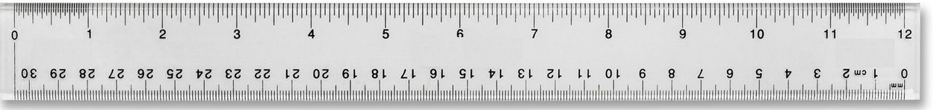

**CONVERTING IMPERIAL**

**EXAMPLE 1** (INCHES TO FEET)

If an item is  long, how many complete feet is it? Are there any leftover inches?

**EXAMPLE 2** (INCHES TO FEET)

If an item is  long, how many complete feet is it? Are there any leftover inches?

**EXAMPLE 3** (FEET TO INCHES)

If an item is 7 feet long, how many inches is it?

**EXAMPLE 4** (FEET TO YARDS)

Convert 6 feet into yards. How many complete yards is it? Are there any leftover feet?

**EXAMPLE 5** (FEET TO YARDS)

Convert 7 feet into yards. How many complete yards is it? Are there any leftover feet?

**PUTTING IT TOGETHER**

Show that 50 inches is: 50 inches = 1 yard 1 foot 2 inches

|  |
| --- |
| **Guide:**   1. Convert 50 inches into feet   50 inches = 4.16666…   1. We know 4 complete feet. Convert the leftovers back into inches.   *(4 feet would be 48 inches. There are two inches left to make up.)*  50 inches = 4 feet 2 inches   1. Convert the 4 feet into yards.   4 feet = 1.33333…. yards   1. We know 1 complete yard. Convert the leftovers back into feet.   *(1 yard would be 3 feet. There is one foot left to make up.)*  4 feet = 1 yard 1 foot   1. All together:   50 inches = 1 yard 1 foot 2 inches |

**TRY**

Convert 126 inches into yards, left-over feet, and left-over inches.

**CONVERTING METRIC / IMPERIAL  
EXAMPLE 6**Convert 6ft. 2 in. to inches, then centimeters.

**EXAMPLE 7**Convert 52 km into miles

**ASSIGNMENT**

1. Convert:

a) 8 ft. to inches b) 25 yd. to feet c) 72 in. to feet

d) 87 ft. to yards e) 248 in. to yards and feet f) 7 ft. 5 in. to inches

g) 63 yd. to feet h) 24 inches = _____ feet i) 2 yards = _______ feet

j) 50 m = _______ km k) 1300cm = _______ m l) 450 cm = ________mm

m) 7.3 dm = _______ dam n) 1300m = _______ hm

**1.3 Converting Units (part 2)**

**POINT**

* Continue practicing conversions
* Learn alternative approaches (unit analysis)
* Examine applications (cost)

|  |
| --- |
| **UNIT ANALYSIS**  When you want to convert **rates** (relevant info top **& bottom**),use unit analysis:  Unit analysis **focuses on units** to know how to convert |

**EXAMPLE 1**

Convert $0.50/cm. into a price per inch:

**EXAMPLE 2**

Convert 100 km/hr into m/s with unit analysis.

**TRY 1**Convert 50 miles/hour into meters/second

**TRY 2**

Mr. Lemko stubbornly refused to buy pepperoni above $0.15 per cm. Sobeys has a sale, trying to trick Mr. Lemko at $0.25 per inch.

Will he buy the pepperoni stick?

**TRY 3**

Baseboards cost $0.35/ft. How much would it cost to finish the following room?

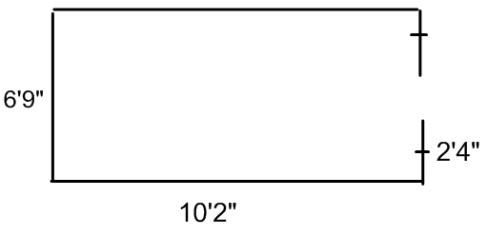

**TRY 4**

Maps use scales like 1: 2000, which means 1 unit on the map is equal to 2000 units in the real world. If you measure 6 cm on the map, how much does that refer to in the real world?

Assignment

pg. 22-23 # 4, 6, 7, 8, 10, 11, 13a, 14, 15

**1.4 Surface Area of Right Pyramids and Cones**

**The Point**

Learn how to calculate the Surface Area of Pyramids and Cones.

**REMINDER 1**

|  |
| --- |
| Pythagorean Theorem:  = |

1. Determine the missing side lengths

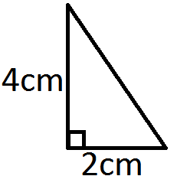

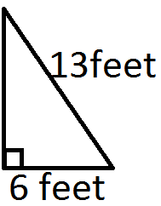

**REMINDER 2**

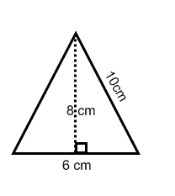 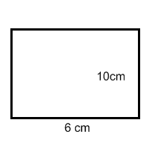 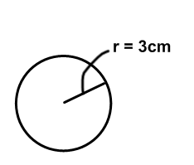

|  |  |  |
| --- | --- | --- |
| Area of a triangle: | Area of a rectangle: | Area of a circle: |

**RIGHT PYRAMIDS**

Draw a “net” for the each pyramid:

|  |  |  |  |
| --- | --- | --- | --- |
|  |  |  |  |

**SLANT HEIGHTS**

The slant height is different from the vertical height.

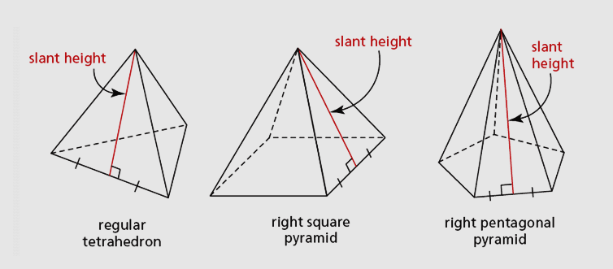

**CALCULATING SURFACE AREA**

EXAMPLE 1

This right square pyramid has a slant height of 10 cm and a base side length of 8 cm. Find its surface area.

SA = 4 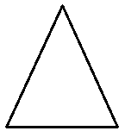 + 1 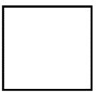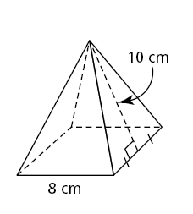

**TRY 1** 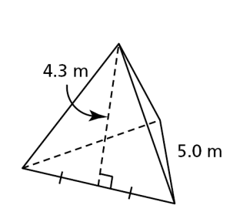

Calculate the area of this **REGULAR TETRAHEDRON.**

(A “regular” shape means each face is identical)

**DEFINITION**

**Lateral area** is the total area of the vertical face(s) of a pyramid

(everything but the base OR the “wrap-around”).

What is the lateral area of “try 1”?

|  |
| --- |
| SAcone = |

**RIGHT CONES** 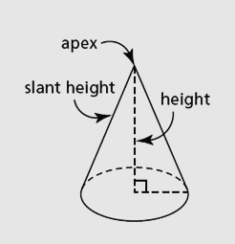

**EXAMPLE 3**

A right cone has a base radius of 4 metres and a vertical height of 10 metres. Calculate the surface area of this cone to the nearest square metre.

DRAW:

**EXAMPLE 4** (working backwards)

The lateral surface area of a square pyramid is 3000 in2. The side length of the base if 50 inches. Determine the **vertical height** of the model, to the nearest tenth of an inch.

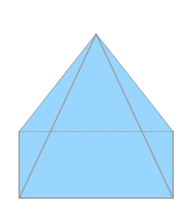

**Super Challenge Question of the Day**

(no slant height given)

A right rectangular pyramid has base dimensions 4 m by 4 m, and a vertical height of 8 m. Calculate the surface area of the pyramid to the nearest square metre.

Assignment: Pg. 34-35

#4b, 5b, 6a, 7a, 9, 11, 16

**1.5 Volumes of Right Pyramids and Cones**

**The Point**

Learn how to calculate the Volume of Pyramids and Cones.

**REMINDER**

Draw a **rectangular pyramid cone**

**VOLUME VS SURFACE AREA**

What is the difference between volume and surface area? What are some typical units?

**CALCULATING VOLUME**

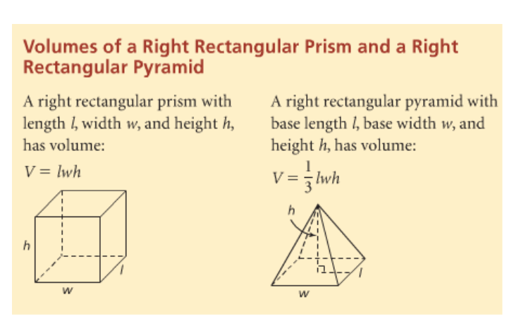

Essentially, it is the area of the Base, times the height:

|  |
| --- |
| **Volume of a pyramid:** |

**EXAMPLE 1**

1. A right rectangular prism has base dimensions of 5.3 cm and 2.6 cm and a height of 10.7 cm. Determine its volume.

1. The same dimensions exist for a right rectangular PYRAMID. Determine its volume.

**EXAMPLE 2**

Indiana Jones is trapped in a right “square” pyramid that is filling with sand. A right square pyramid has a height of 5.3 cm and a base area of 20.7 cm2. Find the volume of sand that will fill it up.



**APPLYING PYTHAGORAS** 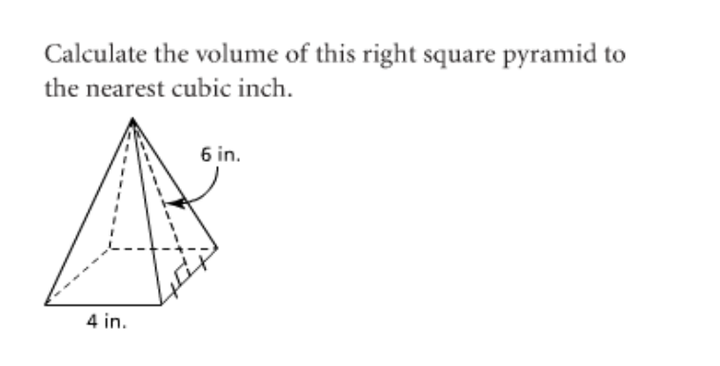

Determine the volume of the pyramid to the right

**CONES CYLINDERS**

|  |
| --- |
| **Volume of a Cone:**    **Surface Area of a Cone:**  *(from last day)* |
| **Volume of a Cylinder:**    **Surface Area of a Cylinder:** |

**EXAMPLE 2**

1. Determine the surface area of the right cylinder to the nearest tenth of a squared cm.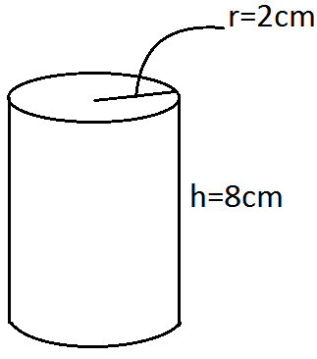
2. Determine the surface area of the right cylinder to the nearest tenth of a squared cm if it has **no top circle**.

c) Determine the volume of the right cylinder to the nearest tenths of a cubic cm.

**EXAMPLE 2**

Determine the volume of the right cone to the nearest cubic inch.

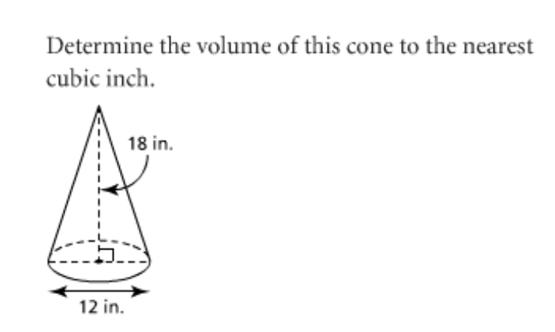

**EXAMPLE 3**

A cone has a radius of 8 m and a volume of 300m3. Determine the length/height to the nearest metre.

Assignment: pg. 42-43

#4b, 5b, 6a, 7a, 10, 11, 12, 18, 21

**1.6 Surface Area and Volume of a Sphere**

**The Point**

Learn how to calculate the Surface Area and Volume of Sphere.

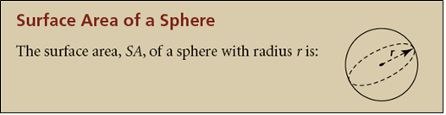

**EXAMPLE 1**

The diameter of a softball is approximately 4 in. Determine the surface area of a softball to the nearest square inch.

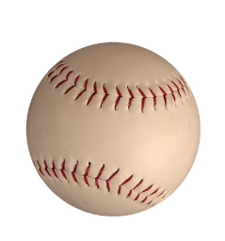

**EXAMPLE 2**

The surface area of a soccer ball is approximately 250 square inches. What is the **diameter** of a soccer ball to the nearest tenth of an inch?

**VOLUME**

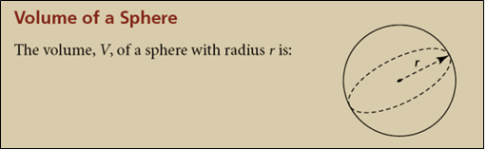

**TRY 2**

An orange approximates a sphere with radius of 2 in. What is the approximate volume of the orange?

**HEMISPHERE FORUMULAS**

1.  b) 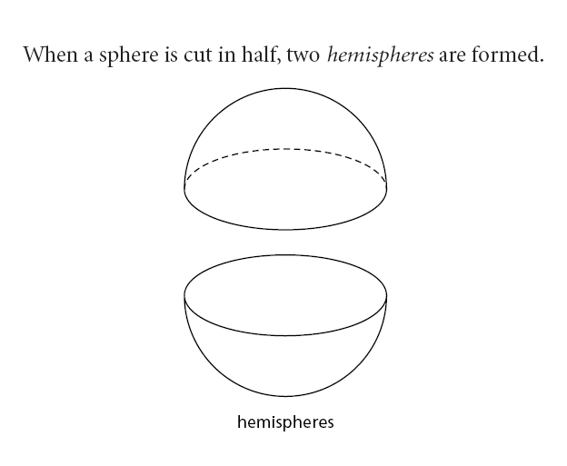

 

**EXAMPLE 3**

A hemisphere has a radius of 5.0 cm.

1. What is the surface area of the hemisphere to the nearest tenth of a square centimetre?
2. What is the volume of the hemisphere to the nearest tenth?

**CHALLLENGE Qs**

**EXAMPLE 4**

The surface area of a hemisphere is 65 cm2. What is the radius?

**CHALLLENGE Qs**

**EXAMPLE 5**

The surface area of a hemisphere is 65 cm2. What is the Volume of the hemisphere?

Assignment: pg.51-52

#3ac, 4ac, 5b, 8, 13, 20

**1.7 Solving Problems Involving Objects**

**The Point**

Learn how to calculate the Surface Area and Volume of Sphere.

|  |
| --- |
| *Your confidence and knowledge of the formulas’ parts will determine success in this topic.* |

**Investigate**

Determine a formula for the following composite shape

**Volume:**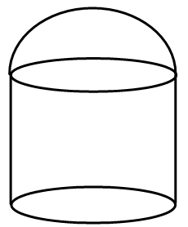

**Area:**

**EXAMPLE 1**

Determine the volume of grain that would fill this bin.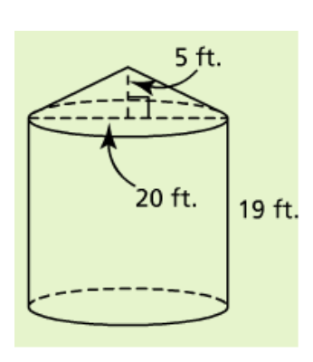

**EXAMPLE 2**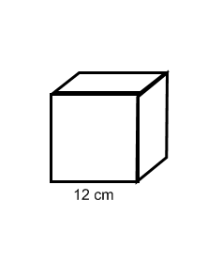

A ball with a diameter of 4 cm fits tightly within a square box so that the side-length equals the diameter of the ball. How much air, to the nearest tenth surrounds the ball, within the box?

**TRY 1**

1. Determine the Volume of the composite object.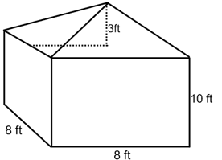

b) Determine the surface area of the composite object

Assignment: pg. 59-60

#3, 5a, 6, 7, 8, 10, 11