**20-1 Unit 7 Chapter 2 TRIGONOMETRY**

*** Your calculator must be in DEGREE mode during this unit!

**2.1 Angles in Standard Position**

**Standard Position**

* Angles are placed in standard position so they can be compared.
* Angles in standard position all have the same perspective and relate to both the x and y axis.

Examples:

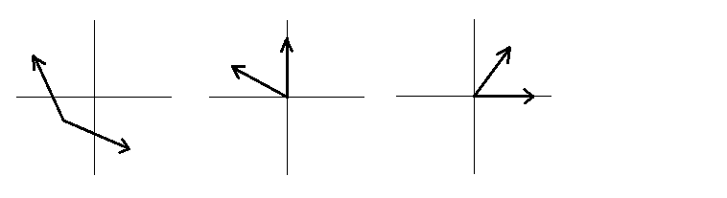

Angles not in Standard Position Angle in Standard Position

θ

terminal arm

initial arm

vertex

**Putting an Angle in Standard Position**

* There are 2 “arms” to any angle
* The initial arm is outstretched from the origin along the x-axis
* The terminal arm is rotated from the initial arm
* Angles can be classified in their quadrant. There are 4 quadrants.

We start the first quadrant from the initial arm and rotate counter-clockwise.

II I

III IV

Examples: Sketch 45°, 120°, 200°, 340° and determine the quadrant of each angle.

**Co–Terminal Angles**

* angles that have the same terminal arm

counter-clockwise (+) Positive angles rotate counter-clockwise

clockwise (−) Negative angles rotate clockwise

Examples: Sketch 405°, 540°, 690°, - 210°, 920°, - 370°

**Principal Angle**

• ***smallest positive*** co–terminal angle (between 0° and 360°)

**Reference Angle**

• ***positive acute*** angle formed by terminal arm & the x–axis (between 0° and 90°)

Example: Find the principal angle and the reference angle for 580o.

Principal =

Reference =

Example: Find the principal angle and the reference angle for 395° and -470° respectively.

Angle: 395° Angle: -470°

Principal Angle: Principal Angle:

Reference Angle: Reference Angle:

Example: Using a reference angle of 25°, find the related angles in all four quadrants. You can flip and reflect the reference angle diagram to locate related angles in each quadrant.

Example: Find one positive and one negative angle co–terminal with each. Also find the principal angle and reference angle for each.

a. 108°

b. −70°

c. 587°

**Practice:**

I. Determine the measures of the following angles.



48°



71°

1. 2. 3.



63°



 4. 5. 6.



56°

29°

84°

II. Determine one positive and one negative angle that is co-terminal with the following.

**1. 2. 3.**

41°

59°

65°

**4. 5.**

33°

52°

**Terminal Arm Length and Special Case Triangles**

**Using Coordinates to Determine Length of the Terminal Arm**

* There are two methods which can be used:
  + Pythagorean Theorem
  + Distance Formula
* Tip: “Always Sketch First!”

Using the Theorem of Pythagoras

* Given the point (3, 4), draw the terminal arm. Complete the right triangle by joining the terminal point to the x-axis.
* Determine the sides of the triangle. Use the Theorem of Pythagoras.
* Since we are using angles rotated from the origin, we label the sides as being x, y and r for the radius of the circle that the terminal arm would make.
* Example: Draw the following angle in standard position given any point (x, y) and determine the value of r.

Point: (-2, 3) Point: (-5, -1) Point: (4, -2)

NOTE: ‘r’ is **always** ____________________________

Using the Distance Formula

* The distance formula: $d=\sqrt{{\left(x_{2}-x_{1}\right)}^{2}+{\left(y_{2}-y_{1}\right)}^{2}}$

Example: Given point P (-2, -6), determine the length of the terminal arm.

**Review of SOH CAH TOA**

Example: Solve for x

1. b)

x

35

x

7

200

74°

Example: Determine the ratios for the following:

1. sin 28°

17

1. cos 28°

28°

1. tan 28°

**Special Case Triangles – Exact Trigonometric Ratios**

* We can use squares or equilateral triangles to calculate exact trigonometric ratios for 30°, 45° and 60°.
* Draw a diagonal in the square to the right.
  + A square with a diagonal will have angles of 45°.
  + All sides are equal.
  + Let the sides equal 1
  + By the Theorem of Pythagoras, r = $\sqrt{2}$
* Draw a perpendicular line from the top straight down the equilateral triangle.
  + All angles are equal in an equilateral triangle (60°)
  + After drawing the perpendicular line, we know the small angle is 30°
  + Let each side equal 2
  + By the Theorem of Pythagoras, y = $\sqrt{3}$

**Finding Exact Values**

* Steps:
  + Sketch the special case triangles and label
  + Sketch the given angle
  + Find the reference angle

30°

60°

1

2



1

1

45°

45°



* Example: Cos 45° Example: Sin 60°

cos 45° sin 60°

* Example: Tan 30° Example: Cos 30°

tan 30° cos 30°

**Solving Equations using Exact Values, Quadrant I ONLY**

Examples:

1. sin x = $\frac{1}{2}$
2. cos x = $\frac{1}{2}$
3. tan x = 1
4. cos x = $\frac{\sqrt{2}}{2}$
5. sin x = $\frac{\sqrt{3}}{2}$
6. cos x = $\frac{\sqrt{3}}{2}$
7. tan x = $\sqrt{3}$
8. sin x = $\frac{\sqrt{2}}{2}$
9. tan x = $\frac{\sqrt{3}}{3}$

**2.2 Trig Ratios of Angles in Standard Position**

**Primary Trig Functions** Reciprocal Trig Functions (Math 30-1)

r

θ

x

y

(x, y)

sin θ =  cosecant (csc) θ = 

cos θ =  secant (sec) θ = 

tan θ =  cotangent (cot) θ = 

Note: r is the reference angle so  is always positive and is always between r and the x axis.

|  |  |
| --- | --- |
| S | A |
| T | C |

II I

III IV

The CAST rule shows where each trig ratio is positive.

Quadrant I – all trig ratios are positive.

Quadrant II – only Sine is positive.

Quadrant III – only Tangent is positive.

Quadrant IV – only cosine is positive.

Examples: How are the elements in each of the following sets related? Compare the following ratios in each set and discuss any observations.

a. cos 43° **ANS:** b. sin 43° **ANS:**

cos 137° **ANS:** sin 137° **ANS:**

cos 223° **ANS:** sin 223° **ANS:**

cos 317° **ANS:** sin 317° **ANS:**

cos −43° **ANS:** sin −43° **ANS:**

Example 1: Given P (3, -4) sketch the triangle and use it to calculate the trig ratios.

sin θ = $\frac{y}{r}$ = csc θ = $\frac{r}{y}$ =

cos θ = $\frac{x}{r}$ = sec θ = $\frac{r}{x}$ =

tan θ = $\frac{y}{x}$ = cot θ = $\frac{x}{y}$ =

Example 2: The following points are on the terminal arm of angle θ. Find the 6 trig ratios.

a. (5, 12)

Determine the 6 trig ratios. sin θ = csc θ =

cos θ = sec θ =

tan θ = cot θ =

b. (2, −3)

Determine the 6 trig ratios. sin θ = csc θ =

cos θ = sec θ =

tan θ = cot θ =

c. (m, m − 5) Find sin θ. (Give it a try.)

Example 3: Find the following ratios using your calculator accurate to 4 decimal places.

a) cos 147° b) tan 280° c) sin 61°

Example 4: Given 140°, sketch and determine the **sign** of the 3 trig ratios

sin is

cos is

tan is

Example 5: Find other angles with the same ratio for the given function. (Between 0° & 360°)

a. sin 38° **ANS:** b. tan 115° **ANS:**

c. cos −72° **ANS:**

**Solving Degree 1 Trigonometric Equations**

* Solving a trig equation means **finding the angle**.
* Since we now know that the positive or negative nature of trig ratios affects the quadrant we are in, we have to consider more than one possible answer.
* Steps: (**QRSS)**
  + Determine the possible quadrants based on the positive or negative value (Q)
  + Calculate the reference value for θ (theta) (R)*
  + Make a sketch (S)
  + Determine possible values for θ, solution (S)

*(To simplify our calculations we use a **positive ratio** to find the **reference** angle.)

*Calculate the following for $0°≤θ<360°$*

Example 6: Cosine θ = 0.4315 to the nearest whole degree.

Example 7: Sine θ = 0.615 to the nearest whole degree.

Example 8: Cosine θ = -0.235 to the nearest whole degree.

Example 9: Tangent θ = -2.43 to the nearest tenth of a degree.

Example 10: Tangent θ = 1/3 to the nearest tenth of a degree.

Example 11: Sine θ = -7/9 to the nearest whole degree.

Example 12: cos θ = , sin θ > 0. Find the other 2 EXACT ratios.

**2.3 Sine Law**

* The Sine Law is used when you have a **side-angle pair** and any other angle or side
* You may have ASA or SSA
* Proof:

B

A

C

b

a

c

x

y

h

sin A = $\frac{h}{c}$ sin C = $\frac{h}{a}$

h = c sin A h = a sin C

Substitute: c sin A = a sin C

Rearrange: $\frac{a}{\sin{A}}$ = $\frac{c}{\sin{C}}$

B

sin A = $\frac{h}{b}$ sin B = $\frac{h}{a}$

y

c

h = b sin A h = a sin B

a

x

h

Substitute: b sin A = a sin B

Rearrange: $\frac{a}{\sin{A}}$ = $\frac{b}{\sin{B}}$

b

C

A

**Sine Law :**

$\frac{a}{\sin{A}}$**= $\frac{b}{\sin{B}}$ = $\frac{c}{\sin{C}}$ or $\frac{sin A}{a}$ = $\frac{sin B}{b}$ = $\frac{sin C}{c}$**

Example 1: Solve the following triangle.

55°

16

12

Example 2: In ΔABC, BC = 20, ˂A = 31°, and ˂C = 104°. Find AC (side b) to the hundredths.

31°

104°

20

A

B

C

Example 3: In ΔXYZ, ˂X = 105°, x = 20.3 and y = 15.1. Find ˂ Y to the nearest degree.

15.1

105°

20.3

Z

Y

X

**The Ambiguous Case**

* The *Ambiguous Case* occurs when you have SSA (angle not included)
* The ambiguous case is solved with the Sine Law **BUT** you must also check for alternate solutions because the solution gives a positive Quadrant I value. Sine is also positive in Quadrant II.

Example 1: Solve triangle ABC if A = 29.3°, b = 20.5 cm and a = 12.8 cm.

C

20.5

12.8

We have two possibilities for the triangle.

Example 2: Calculate the measures of triangle BCD and triangle BDA to the nearest tenth of a centimetre.

30°

A

B

C

16

26

D

Example 3: Solve the following triangles: ΔKLM where M = 37.3°, m = 85 km and l = 90 km.

Example 4: Solve the following triangles: ΔXYZ where X = 120°, x = 40 and z = 20.

Solve the following triangles:

1. ΔABC where B = 27°, b = 25 and c = 30.
2. ΔTUV where U = 48°, v = 15.6 cm and l = 12.6 cm.
3. ΔPQR where P = 30°, p = 24 m and q = 48 m.

Answer the following:

1. Sam is receiving a signal from a beacon that is directly east of his position. Due to poor terrain, he cannot go directly to the beacon. He travels 50 metres at an angle of 20° South of East. Then he travels 30 metres to the beacon.
   1. Sketch and label a possible triangle to represent his path and the beacon.
   2. Calculate the angle at the beacon of the triangle.
   3. Are there any other possibilities?
   4. How far from Sam’s original position is the beacon?

**2.4 The Cosine Law**

* The Cosine Law is used when you do NOT have a side-angle pair
* You may have SSS or SAS
* The Cosine Law is:

$c^{2}= a^{2}+ b^{2}- 2ab\cos{C}$

* The Cosine Law can be rearranged as:

$a^{2}= b^{2}+ c^{2}- 2bc\cos{A}$ $b^{2}= a^{2}+ c^{2}- 2ac\cos{B}$

* The Cosine Law is an extension of the Theorem of Pythagoras. Cosine 90° is zero so the last term will disappear when dealing with a right-angle triangle.
* Proof:

B

A

C

b

a

c

x

b - x

h

cos A = $\frac{x}{c}$ $c^{2}=$ $h^{2}+x^{2}$

x = c cos A $a^{2}=$ $h^{2}+{(b-x)}^{2}$

$a^{2}=$ $h^{2}+{b^{2}-2bx+x}^{2}$

Rearrange: $a^{2}=$ $h^{2}+x^{2}+ b^{2}- 2bx$

Substitute: $a^{2}=$ $c^{2}+ b^{2}- 2bc\cos{A}$

Rearrange: $a^{2}=$ $b^{2}+ c^{2}- 2bc\cos{A}$

* The Cosine Law can be rearranged to solve for the angle.

$\cos{C}= -\frac{{(c^{2}-a}^{2}- b^{2})}{2ab}$

Example 1: In triangle DEF, what is the value of side e to the nearest thousandth if d = 5, ˂E = 74° and f = 3.

3

5

74°

Example 2: Find ˂C to the nearest degree if a = 12, b = 18 and c = 15 in ΔABC.

B

12

18

15

Example 3: Solve the following triangle. Give all answers to the nearest tenth.

P

58°

R

Q

13.8

16.4

**Solving Word Problems Using Sine and Cosine Laws**

1. Points A and B are on opposite sides of the Grand Canyon. Point C is 500 metres from A. Angle B measures 87° and angle C measures 67°. What is the distance between A and B? (±0.1m)

2. Two observers are standing on shore ½ km apart at points A and B and measure the angle to a sailboat at a point C at the same time. Angle A is 63° and angle B is 56°. Find the distance from each observer to the sailboat. (±0.1m)

3. A person at A looks due east and sees a UFO with an angle of elevation of 40°. At the same instant, another person, 1.0 km **due west of A** looks due east and sights the same UFO with an angle of elevation of 25°. Find the distance between A and the UFO. How far is the UFO above the ground? (±0.01km)

4. A vertical flagpole is attached to the top edge of a building. A man stands 400 feet from the base of the building. From his viewpoint, the angle of elevation to the bottom of the flagpole is 60°; to the top is 61°. Determine the height of the flagpole. (±0.1ft.)

5. In a recreation park a children’s slide is 27 feet long and makes an angle of 39°with the ground. Its top is reached by a ladder 18 feet long. What is the angle of inclination of the ladder to the nearest whole degree?

6. A small town is separated from the local power plant by mountainous terrain and several lakes. Until now, electrical power has been routed through a nearby city. The recent development of a stronger wire permits a direct line to be constructed. Sighting from the town, the angle between the city and the power plant is 77°. The distance between the city and the town is 123 km. The distance from the power plant to the city is 156 km. What is the distance "as the crow flies" between the town and the power plant? (±0.1km)

7. Two pedestrians walk from opposite ends of a city block to a point on the other side of the street. The angle formed by their paths is 25°. One pedestrian walks 300 feet, the other walks 320 feet. How long is the city block? (±0.1ft.)

8. Points A and B are sighted from point C. If C = 98°, AC = 128 m and BC = 96 m, how far apart are points A and B? (±0.1m)

9. Two sides and the included angle of a parallelogram have measures 3.2, 4.8, and 54°respectively. Find the lengths of the diagonals. (±0.1)

10. The lengths of two sides of a parallelogram are 24.6 inches and 38.2 inches. The angle at one vertex has measure 108°. Find the lengths of the diagonals. (±0.1in.)

11. A bridge is supported by triangular braces. If the sides of each brace have lengths 63 feet, 46 feet and 40 feet, find the measure of the angle opposite the 46 ft side to the nearest whole degree.

12. The measures of two sides of a parallelogram are 28 cm and 42 cm. If the longer diagonal has measure 58 cm, find the measures of the angles at the vertices to the nearest whole degree.

13. On a baseball diamond with 90-foot sides, the pitcher’s mound is 60.5 feet from home plate. How far is the pitcher’s mound from third base? (±0.1ft.)

14. On a map, Orlando is 178 mm due south of Niagara Falls, Denver is 273 mm from Orlando, and Denver is 235 mm from Niagara Falls. Find the measure of the angle to the nearest degree at Niagara Falls between Denver and Orlando, and then at Orlando between Denver and Niagara Falls to the nearest degree.

SOLUTIONS

1. 460.9 m

2. Observer A: 473.9 m

Observer B: 509.4 m

3. Between A & UFO: 1.63 km

UFO height: 1.05 km

4. 28.8 ft.

5. 71°

6. 127.5 km

7. 135.6 ft.

8. 170.4 m

9. Long Diagonal: 7.2

Short Diagonal: 3.9

10. Long Diagonal: 51.4 in.

Short Diagonal: 38.5 in.

11. 47°

12. 110° & 70°

13. 63.7 ft.

14. Denver & Orlando: 81°

Denver & Niagra Falls: 58o

**Solving Linear Trig Equations**

**A. Calculator**

Solve ****(1 revolution) 

**1. **

**2.  3. **

Solve ****(1 revolution)

4. 2 + 1 = 0

0 ≤ θ < 360° (±0.01)

5. 3 − 1 = 0 6. 5 + 3 = 0

**Trigonometry Review Notes:**

**Rotation Angle:**

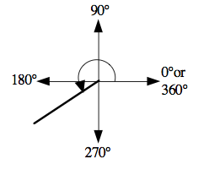The angle from the positive x-axis to a terminal arm rotated in the counter clockwise direction about the origin.

The diagram to the right shows

a rotation angle of 220° in

standard position

**Positive angles** result from a counter clockwise rotation

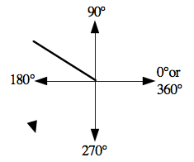

**Negative angles** result from a clockwise rotation.

**Reference Angle:**

The acute angle formed between the terminal

arm of the rotation angle and the x-axis.

**Pythagorean Theorem**

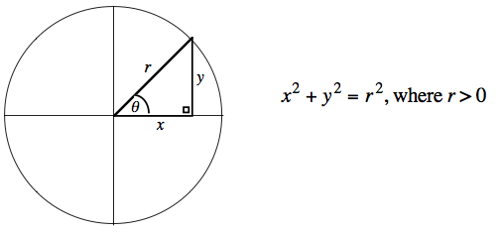

**Trigonometric Ratios** Remember: **SOH CAH TOA!!!**

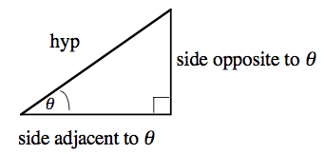

$$\sin{θ}=\frac{opp}{hyp}$$

$$\cos{θ}=\frac{adj}{hyp}$$

$$\tan{θ}=\frac{opp}{adj}$$

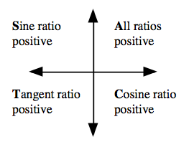**CAST Rule**

Tells us in which quadrants the trigonometric ratios are positive.

The ratios not mentioned are negative.

**Exact Values and Special Triangles**

You should be able to determine the exact value of sin, cos, and tan ratios for a given reference angle of 0**°, 3**0**°,** 45**°**60**°, 9**0**°.**

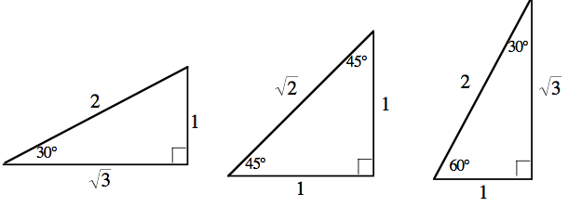

Know these triangles!!!

**Sine and Cosine Laws**

You cannot use SOH CAH TOA on triangles that do not have a right angle.

In a non-right triangle use:

The **Cosine** Law if you are given SSS or SAS

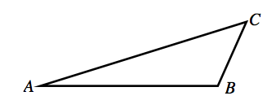

$a^{2}=b^{2}+c^{2}-2bc\cos{A}$

The **Sine** Law in all other cases.

$\frac{a}{Sin A}=\frac{b}{Sin B}=\frac{c}{Sin C}$

**Ambiguous Case for the Sine Law**