**UNIT 1, part 2 CHAPTER 4: QUADRATIC EQUATIONS**

**4.1 GRAPHICAL SOLUTIONS OF QUADRATIC EQUATIONS**

* Second degree equation: *ax² + bx + c = 0*

You can solve a quadratic equation of the form *ax² + bx + c = 0*  by graphing the corresponding function, *f(x) = ax² + bx + c.*

The solutions to a quadratic equation are called the **roots** of the equation. You can find the roots of a quadratic equation by determining the **x-intercepts** of the graph, or the **zeros** (y = 0) of the corresponding quadratic function.

Example 1: What are the solutions to the quadratic equation graphed below?



**A.** What would a quadratic equation with **one real root** look like?

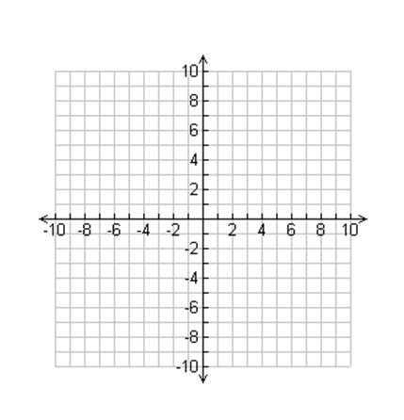

Ex 2. a) Determine the roots of the quadratic equation *x² - 6x + 9 = y.* Make *y = 0* then solve for *x* by factoring.

b) How can we check to see if the answer we found is correct?

**B.** What would a quadratic equation with **two distinct real roots** look like?



Ex 3. a) The manager at Suzie’s Fashion store has determined that the function

***R(x) = – 6x² + 600*** models the expected weekly revenue, *R,* in dollars, from sweatshirts as the price changes, where *x* is the change in price, in dollars. What price increase or decrease will result in no revenue? Factor to find the values of *x* when R(x) = 0 Show this in a sketch of the function. Be sure to label!!

b) Do both price changes make sense? Why or why not?

c) Why is this an example of two distinct real roots?

**C.** What would a quadratic equation with no real roots look like?

Ex. Solve *3x² - x = -2* by graphing.

Are there any zeros for this function? Why or why not?

Summary:

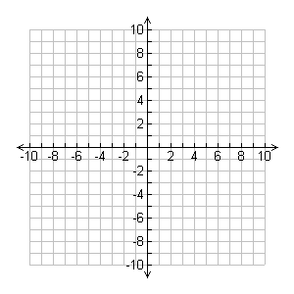No real roots One real root Two real roots

What words, specific to quadratics, are synonymous with solutions?

**4.2 FACTORING QUADRATIC EQUATIONS**

Recall Factoring from 10Common: ☺

* Difference of squares
* Perfect Square Trinomials
* Quadratics a=1
* Quadratics a≠1

**Factoring Polynomials having a Quadratic Pattern:**

Factor the following:

a) $4x² - 0.25y²$

b) $12x^{2}-10x-8$

c) $12x² + 24x + 9$

d) ${\left(x+2\right)}^{2}+7(x+2)+12$

**SOLVING Quadratic EQUATIONS by Factoring**

The **roots** of a quadratic equation occur when the product of the factors = zero.

To solve a quadratic equation:

1. factor the expression and
2. set EACH factor equal to zero and
3. solve for the variable.

Determine the **roots** of each quadratic equation.

a) x² - 10x + 25 = 0

b) x² - 16 = 0

c) 3x² - 2x – 8 =0

**FACTORING QUADRATIC EQUATIONS II**

What does it mean to solve a quadratic equation?

How can you solve a quadratic equation?

What are the solutions to a quadratic equation called?

Application Problems:

Ex. 1 A waterslide ends with the slider dropping into a deep pool of water. The path of the slider after leaving the lower end of the slide can be approximated by the quadratic function: $-\frac{1}{6}d^{2}-\frac{1}{6}d+2$, where *h* is the height above the surface of the pool and *d* is the horizontal distance the slider travels from the lower end of the slide, both in feet. What is the horizontal distance the slider travels before dropping into the pool after leaving the lower end of the slide?

Ex. 2 The length of an outdoor lacrosse field is 10m less than twice the width. The area of the field is 6600m². Determine the dimensions of an outdoor lacrosse field.

Ex. 3 The area of a rectangular ping-pong table is 45ft². The length is 4ft more than the width. What are the dimensions of the table?

**4.3 SOLVING QUADRATIC EQUATIONS BY COMPLETING THE SQUARE**

Sometimes factoring quadratic equations is not practical. You can **complete the square** to solve quadratic equations.

**Graph the function** *f(x)* = x² - 8x + 5

* What are the x-intercepts? How accurate are your answers? Why might it be important to determine more accurate zeros for the function?

* Rewrite the in the form *h(x) = a(x-p)² + q* by completing the square.
* Set the equation equal to 0 and solve for x. This method is “solving by completing the square”. Express answers as **exact values**.

You can solve quadratic equations of the form *ax² + bx + c = 0*, where *b = 0* or of the form

*a(x – p)² + q = 0*, where *a≠0*, that have real-number solutions, by isolating the squared term and taking the square root of both sides. **The square root of a positive real number can be positive or negative, so there are two possible solutions to these equations.**

Ex. Solve and check *(x – 1)² - 49 = 0*

In summary, many quadratic equations cannot be solved by factoring. In addition, graphing the corresponding functions may not result in exact solutions. Factoring, graphing and completing the square are all possible avenues to finding the zeros of a function.

Ex. Solve *p² - 4p = 11 by completing the square. Express to nearest tenth.*

Ex. A wide screen television has a diagonal measure of 42in. The width of the screen is 16in. more than the height. Determine the dimensions of the screen, to the nearest tenth of an inch and in **exact** measurements.

h +16

42in

h

Ex. Determine the roots of *-2x² - 5x +2 = 0,* then verify your answer using technology.

Ex. How far does the soccer ball travel before it hits the ground if the trajectory of the ball is modeled by the function *h(x) = -0.016x² + 1.152x – 15.2,* where the *x* is the horizontal distance travelled, in metres, from the goal line and *h* is the height, in metres.

**4.4 THE QUADRATIC FORMULA PART I**

By completing the square, we can develop a formula that allows you to solve any quadratic equation in standard form.

**The Quadratic Formula**

$$x=\frac{-b±\sqrt{b^{2}-4ac}}{2a}$$

We use the quadratic formula when we cannot factor or completing the square is complex.

Ex. Given $3x^{2}+5x-2=0$

**The Discriminant**

You can determine the nature of the roots (0, 1, or 2) for a quadratic equation by the value of the discriminant.

The **discriminant** is located **under the radical sign in the quadratic formula: $b^{2}-4ac$**

* When the value of the discriminant is **positive, $b^{2}-4ac>0$** , there are two distinct roots.



* When the value of the discriminant is **zero**, $b^{2}-4ac=0$, there is one distinct root, or two equal real roots.



* When the value of the discriminant is **negative**, $b^{2}-4ac<0$, there are no real roots.



Ex. Use the discriminant to determine the nature of the roots for each quadratic equation. Check by graphing.

a. $x^{2}-5x+4=0$



b. ${3x}^{2}+4x+\frac{4}{3}=0$



c. ${2x}^{2}-8x=-9$

Ex. Determine the roots for each quadratic equation. Express your answers to the nearest hundredth and exact answers.

a. ${3x}^{2}+5x-2=0$

b. $\frac{t^{2}}{2}-t-\frac{5}{2}=0$

Ex. Solve $6x^{2}-14x+8=0$ by:

* Graphing
* Factoring
* Completing the square
* Quadratic formula

Which strategy do you prefer?

**4.4 THE QUADRATIC FORMULA II**

Ex. 1 Sipapu Natural Bridge is in Utah. Find the horizontal distance, in metres, across this natural arch if it is represented by the equation: $-0.04x^{2}+3.28x=0$ Solve algebraically.

Ex. 2 If 4 times the square of a number is 81, what is the number?

Ex. 3 Leah wants to frame an oil original painted on canvas measuring 50cm by 60cm. Before framing, she places the painting on a rectangular mat so that a uniform strip of the mat shows on all sides of the painting. The area of the mat is twice the area of the painting. How wide is the strip of exposed mat showing on all sides of the painting, to the nearest tenth of a centimetre.

Ex. 4 Two small private planes take off from the same airport. One plane flies north at 150 km/h. Two hours later, the second plane flies west at 200 km/h. How long after the first plane takes off will the two planes be 600 km apart? Express your answer to the nearest tenth of a hour.