**MATHEMATICS 30-1**

Course Syllabus

Mrs. Orchard – Quarter 1, 2020

Name:___________________________

**Course Schedule**

|  |  |  |
| --- | --- | --- |
| **UNIT** | **CLASSES** | **EXAM DATES**  **(may vary slightly) MARK %** |
|  |  |  |
| 1. Transformations and Functions; Radical Functions (Ch 1&2) | 7 | Sept 10 _______ |
|  |  |  |
| 2. Polynomial Functions (Ch 3) | 4 | Sept 17 _______ |
|  |  |  |
| 3. Rational Functions; Function Operations (Ch 9 & 10) | 5 | Sept 25 _______ |
|  |  |  |
| 4. Exponents and Logarithms (Ch 7 & 8) | 6 | October 6 _______ |
|  |  |  |
| 5. Trigonometry: unit circle, functions, graphs (Ch 4 & 5) | 5 | October 16 _______ |
|  |  |  |
| 6. Trigonometric Identities (Ch 6) | 4 | October 23 _______ |
|  |  |  |
| 7. Permutations and Combinations (Ch 11) | 4 | October 30 _______ |
|  |  |  |
|  |  |  |
|  |  |  |
| **DIPLOMA EXAM** |  | Friday, November 6 |
| **Contact info:** [**alice.orchard@eips.ca**](mailto:alice.orchard@eips.ca) |  |  |
|  |  |  |
|  |  |  |
|  |  |  |
|  |  |  |

**Course Description**

Mathematics 30-1 builds on key concepts from Mathematics 20-1. Learning through problem solving is the key focus. Students develop and refine their own way of solving problems and show their work in a variety of ways. Students use mathematical vocabulary to explain how they solve problems and continue to acquire the mathematical processes of communication, making connections, mental mathematics, and visualization, and the use of technology as a tool.

Students who believe they can learn, take risks and persevere in problem solving will be successful mathematics students.

The topics in Mathematics 30-1 include:

* Trigonometry: develop trigonometric reasoning
* Relations and Functions: develop algebraic and graphical reasoning through the study of relations
* Permutations, Combinations and Binomial Theorem: develop algebraic and numeric reasoning that involves combinatorics

**Evaluation**

There will be a unit exam after each unit. In addition to the 7 unit exams, assignments designed to promote understanding will occur throughout the course**.**

Opportunity to improve an exam mark will be offered at specified points throughout the semester. Rewrite opportunities will be at the teacher’s discretion after you have filled out a re-write form and have displayed evidence of practice and attention to further your learning. **Staying on task and keeping pace with the class is important**. Writing UNIT STUDY NOTES are strongly encouraged.

The mark you achieve in class will be worth 70% of your final Math 30-1 mark, leaving the Diploma exam worth 30% of your final mark.

|  |  |  |
| --- | --- | --- |
| **Categories** | **Chapters in Text** | **Weight (%)** |
| Relations and Functions | 1: Transformations  2: Radicals  3: Polynomials  9: Rationals  10: Operations & Compositions | 41 |
| Exponents and Logarithms | 7: Exponents  8: Logarithms | 15 |
| Trigonometry | 4: Trigonometry and the Unit Circle  5: Trigonometric Functions  6: Trigonometric Identities | 29 |
| Perms Combs and Bin. Thm | 11: Perms, Combs, Binomial Theorem | 15 |

**Exams and assignments**

**Exams and assignments**

1. If you are absent for an exam, you are required to write the exam **upon your return** at an agreed upon time and location.
2. Please be aware that everything counts. All work assigned (assignments, quizzes, exams) may be used to determine your grade in this course. Once an assignment or quiz is handed back to the students, any late assignments will not be accepted for the purpose of assessment.

**Required Materials**

Pre-Calculus 12 textbook (for review, extra questions) & workbook (The Red Book), a binder, a pencil, and a graphing calculator.

**Classroom Expectations**

1. **Give your best effort every day; ask questions when you don’t understand. DO NOT FALL BEHIND!**
2. Attend class regularly.
3. Conduct yourself in a **courteous**, **respectful** manner and comply with all school rules listed in the online student agenda.
4. If you are late*, enter the room in a respectful manner and sign in.
5. Sign out when needing to leave for a washroom break.
6. Bring your required materials to class every day.
7. Not use personal electronics (phones, music, games) unless directed to do so.
8. Review notes and class work every night and complete homework as assigned.

**DO NOT PRACTICE UNTIL YOU GET IT RIGHT. PRACTICE UNTIL YOU DON’T GET IT WRONG.**

1. Preparation to leave the classroom at the end of the period includes ensuring that your work area is neat and sanitized per directions.

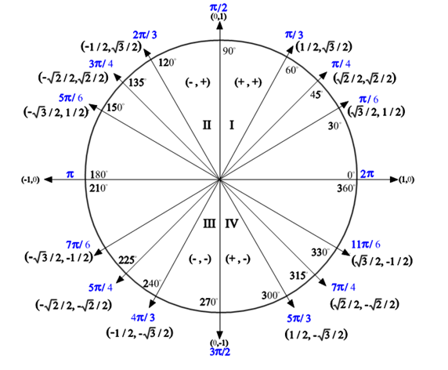

Period for sine and cosine: 360o or 2π

Period for tangent: 180o or π

In an equation:

period =  (for degrees) period =  (for radians)

**Transformations of Trigonometric Functions**

**y =** asin[b(x - c)] + d

**horizontal**

**translation**

(Phase shift)

-just like before

**vertical**

**translation**

(Vertical

displacement)

-just like before, PLUS, it cuts the graph in half horizontally...good to know!

**horizontal stretch**

by a factor of 1/b

value of **b** HELPS

you find the **period**

**('b' is NOT the**

**period!!!!!!)**

**amplitude**

(vertical stretch by a

factor of 'a')

Amplitude = max - min

2

Think: distance away

from 'centre line', which

is the **value of 'd'**

**\*\*Reflection: -a, +a**

|  |  |
| --- | --- |
| **Interval Notation:** (description) | (diagram) |
| Open Interval:   (*a, b*)  is interpreted as *a < x < b* where the endpoints are NOT included. (While this notation resembles an ordered pair, in this context it refers to the interval upon which you are working.) | (1, 5) http://www.regentsprep.org/Regents/math/ALGEBRA/AP1/openintervalpic2.gif |
| Closed Interval:  [*a, b*]  is interpreted as *a < x < b*  where the endpoints are included. | [1, 5] http://www.regentsprep.org/Regents/math/ALGEBRA/AP1/closedintervalpic2.gif |
| Half–Open Interval:  (*a, b*]  is interpreted as *a < x < b* where a is not included, but b is included. | (1, 5] http://www.regentsprep.org/Regents/math/ALGEBRA/AP1/halfintervalpic2.gif |
| Half–Open Interval:  [*a, b*) is interpreted as *a < x < b* where a is included, but b is not included. | [1, 5) http://www.regentsprep.org/Regents/math/ALGEBRA/AP1/halfintervalpic3.gif |
| Non–ending Interval: $(a,∞$ ) is interpreted as *x > a* where *a* is not included and infinity is always expressed as being "open" (not included). | http://www.regentsprep.org/Regents/math/ALGEBRA/AP1/infiniteinterval.gif |
| Non–ending Interval: $\left(-∞,b\right]$  is interpreted as *x < b* where *b* is included and again, infinity is always expressed as being "open" (not included). | http://www.regentsprep.org/Regents/math/ALGEBRA/AP1/infiniteinterval2.gif |

