**UNIT 3 Factors & Products, Chapter 3**

**3.1 Factors & Multiples of Whole Numbers**

To *factor a whole number* means to determine the **prime number factors** that multiply to equal that number. (Remember a prime number has only itself and 1 as factors.)

Most efficiently, use a **factor tree** to do this. Example:

630

10 x 63

2 x 5 x 9 x 7

2 x 5 x 3 x 3 x 7

This is a *prime factorization* of 630.

630 = 2 x 5 x 32 x 7

Or – divide out successive primes, starting with 2, then 3, etc. (Method 2 p. 135)

The *greatest common factor* (GCF) of two or more numbers is the largest number that will divide into all of the numbers.

One way to determine the GCF is by determining the prime factorization of each number. The GCF will be the product of the common primes (primes appearing in each set of factors.) Example:

Find the GCF of 192 and 36.

192 = 2 x 2 x 2 x 2 x 2 x 2 x 3

36 = 2 x 2 x 3 x 3

Common primes are 2, 2, and 3; GCF is 2 x 2 x 3 = **12.**

The *least common multiple* (LCM) of two or more numbers is the smallest number that can be **divided** by each number.

Again, determine the prime factorization of each number. Determine the *prime multiplicity* for each number; three 2’s, two 5’s, etc. The LCM will have at least one of all the primes, with the quantity of each prime equal to the largest prime multiplicity (look at exponent) found in any of the numbers. Example:

Find the LCM of 72 and 132.

72 = 2 x 2 x 2 x 3 x 3 Primes are 2 and 3:

23

- three 2’s - two 3’s

32

132 = 2 x 2 x 3 x 11 Primes are 2, 3 and 11:

- two 2’s (22)

- one 3 (31)

111

- one 11

LCM will contain at least one of 2, 3, and 11. LCM will need to have: - three 2’s

- two 3’s

- one 11

LCM = 23 x 32 x 11 = 792

Or – list the multiples of each number until the same multiple appears in all three lists (Method 1, page 137.)

**Polynomials**

**1. Polynomial**

is an expression consisting of variables and real numbers . The exponents of the variables must be whole numbers.

Ex. Circle the polynomials within the expressions below:

3x + 11 x +   7x2y − 3 

(x – 7)(x + 3)

**2. Coefficient**

is the number immediately preceding a variable in a term.

Ex. a) −4x2 + 7x, the coefficients are ________________________.

b) x3 – x2 - 3, the coefficients are ________________________.

**3. Degree of a term**

The sum of the exponents of the variables in the term.

Ex: 9x4 + 3x2 + 7

Degree = 4 2 0

**4. Degree of a polynomial.**

Degree of a polynomial is determined by the term with the highest degree.

Ex: 4y10 − 6y7 + 2y3 − 4

Degree = 10 7 3 0 Degree of this polynomial is ________.

**5. Constant term.**

The term which has no variable.

Ex: a. 3x3 + 7x2 − 6 Constant term is_____________

b. 7x5  Constant term is_____________

**6. Classifying polynomials according to the degree of the polynomial.**

Degree Name Examples________

0 constant −11

1 linear 7x + 2

2 quadratic 2x2 − 7x + 3

3 cubic 5x3 + 8x2 − 9x − 6

Questions

|  |  |  |  |  |
| --- | --- | --- | --- | --- |
|  | Number of terms | Degree of polynomial | Name according to Degree | Name according to # of terms |
|  |  |  |  |  |
| 5x3 + 21x2 − x |  |  |  |  |
| 454 |  |  |  |  |
| 6x3 − 7x2 + 8x − 66 |  |  |  |  |
|  |  |  |  |  |
| 7x |  |  |  |  |

**ADDING & SUBTRACTING POLYNOMIALS**

**A.** To **add polynomials**, group like terms, then combine the terms by adding their coefficients.

• To add: (8*x* + 7) + (3*x*2 + 2*x* – 3)

(8*x* + 7) + (3*x*2 + 2*x* – 3) Remove the brackets.

= 8*x* + 7 + 3*x*2 + 2*x* – 3 Collect like terms.

= 3*x*2 + 8*x* + 2*x* + 7 – 3 Combine like terms.

= 3*x*2 + 10*x* + 4

**B.** To **subtract polynomials**, use the properties of integers.

Subtracting an integer is the same as adding the opposite integer.

So, to subtract a term, add the opposite term.

• To subtract: (3*n*2 + 7*n*) – (2*n*2 – 4*n*)

(3*n*2 + 7*n*) – (2*n*2 – 4*n*) Subtract each term.

= 3*n*2 + 7*n* – (2*n*2) – (–4*n*) **Multiply the -1 through the brackets!**

= 3*n*2 + 7*n* – 2*n*2 + 4*n* Collect like terms.

= 3*n*2 – 2*n*2 + 7*n* + 4*n* Combine like terms.

= *n*2 + 11*n*

**Check Your Understanding**

**1.** Add or subtract.

**a)** (6*x* + 3) + (2*x* + 5) **b)** (2*x*2 + 6*x* – 5) + (–4*x*2 – 3*x* + 7)

**c)** (5*a* – 8) – (2*a* + 3) **d)** (3*a*2 – 2*a* + 6) – (–2*a*2 + 7*a* – 9)

**e)** (–7 + 3*d*2 – 2*d*) + (8 – 4*d*2 + 3*d*) **f)** (5*e* – 9 + 2*e*2) – (2*e*2 – 9 + 5*e*)

**g)** (10*v* – 5*v*2 – 2) + (3*v* – 7*v*2 – 1) **h)** (*m* – 3*m*2 – 5) – (3*m*2 + 5 – *m*)

**Answers**

**1. a)** 8*x* + 8 **b)** –2*x*2 + 3*x* + 2

**c)** 3*a* – 11 **d)** 5*a*2 – 9*a* + 15

**e)**  – *d*2 + *d*+1**f)** 0

**g)** – 12*v*2 +13*v*- 3

**h)** –6*m*2 + 2*m* – 10

**Assignment:**

Practice Adding & Subtracting Polynomials worksheet**3.7 MULTIPLYING POLYNOMIALS**

**A. Multiplication Monomial by Monomial**

Ex: 1. (3x3)(2x2) = 6x5 2. (−4a2b3)(2ab) = ______________

3. (8x3y2) = ____________ 4. (−4x3y2)(2xy3)(−2xy) = _______________

**B. Distributive Property - Monomial multiplied by a Binomial/Trinomial.**

**1.** 3x2(2x − 7y + 2) **2.** 3(2x2 − 7) + x(2x + 5) − (8x2 + 5x − 7)

=

**3.** 9 − 2(3x + 5) **4.** 4a(a + 3) + 2a(a − 1) − a(2a + 4)

**5.** 3x − 2[3 + 4(2x + 6)] − [2 + 3(x + 1)] Complex Question!

Distribute the 4 and the 3.  
 Distribute the –2 and the –.  
 Clean up.

**C. Multiplying Binomial x Binomial**

**Multiply **

Method 1 – Algebra Tiles

a) 

Step 1 – Draw (x + 3) on the vertical axis and (y + 1) on the horizontal axis.

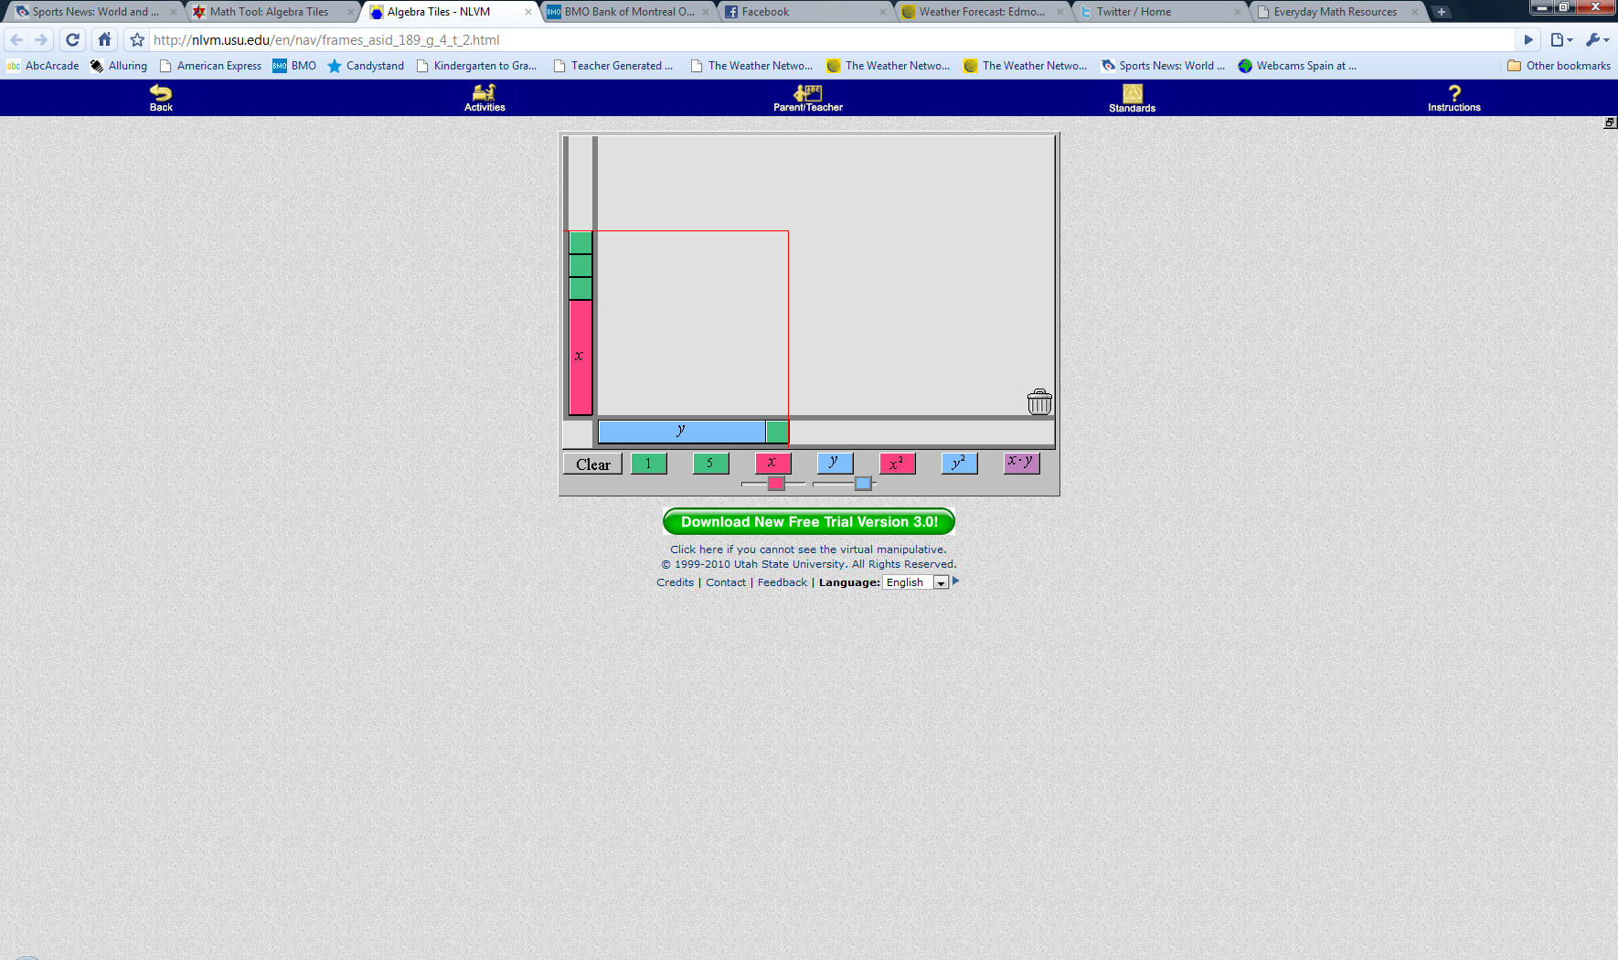  
 Step 2 – Multiply the vertical and horizontal values and fill in the rectangle.

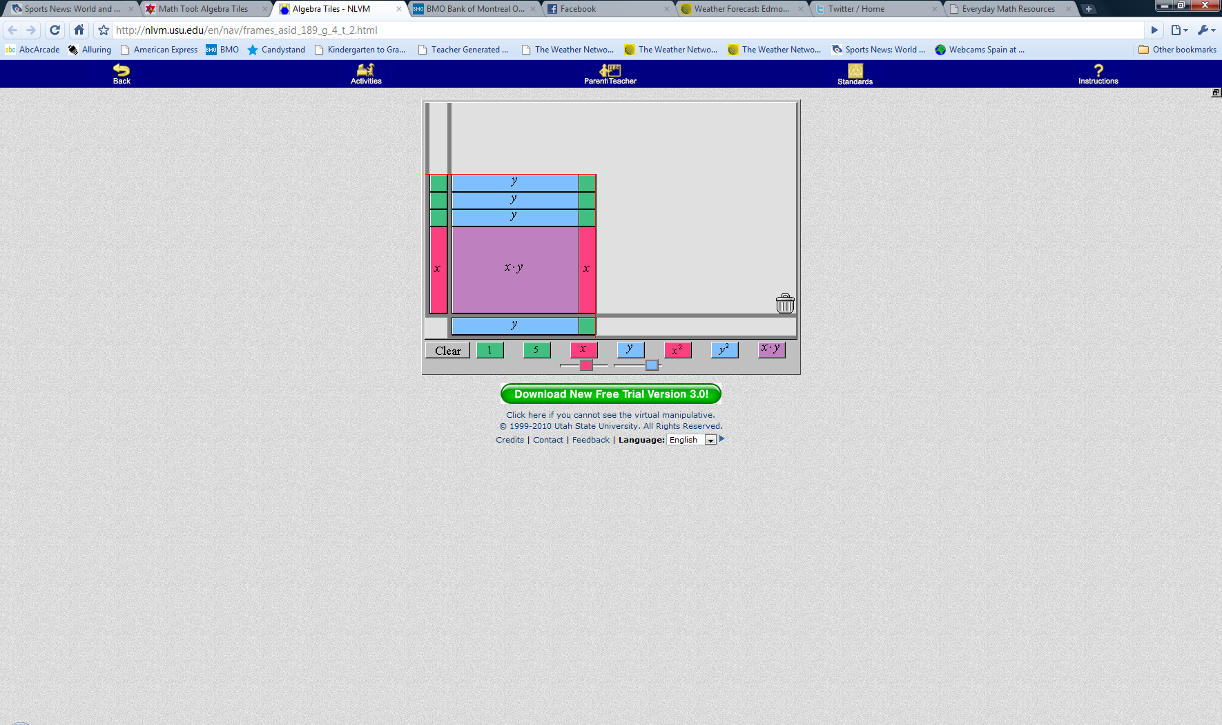

Step 3 – Determine your final product.

There is *1 xy*, *1 x*, *3 y's* and *3 ones*. So, the answer is 

Method 2 – Area model

Step 1 – Create a square grid with (x + 3) on the vertical axis and (x + 1) on the horizontal axis.

|  |  |  |
| --- | --- | --- |
|  | x | +1 |
| x |  |  |
| +3 |  |  |

Step 2 – Fill in the grid

|  |  |  |
| --- | --- | --- |
|  | y | +1 |
| x |  |  |
| +3 |  |  |

Step 3 – Determine your final product.

Method 3 – FOIL (First, Outer, Inner, Last)



** First** x *times* x = x2

** Outer** x *times* 1 = x

** Inner** 3 *times* x = 3x

 **Last** 3 *times* 1 = 3

You now collect your terms:

**Multiply  Two binomials that "are the same" but different signs.**

a) 

**FOIL** (First, Outer, Inner, Last)



 **First** 2a times 2a = 

 **Outer** 2a times 3b = 6ab

 **Inner** –3b times 2a = –6ab

 **Last** –3b times 3b = -

Answer:_________________________________  
b) $(x-3)(x+3)$

When dealing with **conjugates** (that's what  are called), you can save some time by using the “shortcut”

c) 

**Multiply  Squaring a binomial.**

a) 

Let's realize that  is no different than  and we know how to multiply two binomials

But wait! Squaring a binomial  has a shortcut!

Let's try the previous question again.

a)  When you are squaring a binomial, here is the shortcut... square the first, square the last, multiply the two terms and double the coefficient. Easy, right?

**Applications**

Find the area of the **shaded** region.

4x + 6

3x − 2

2x + 4

5x − 4

A = ALarge − ASmall

**Multiplication and simplifying of:**

* 1. Monomial x Polynomial
* 2. Binomial x Binomial

3. Polynomial x Polynomial

Examples

**1.** (3x − 2)(x2 + 5x − 7) **Distribute** the () into the trinomial  
 The 3x multiplies into the trinomial and then the –2 multiplies into the trinomial.



**2.** 4a(a + 3) **+** 2a(a − 1) **−** a(2a + 4)

**3.** (2x − 1)(x + 3) **−** (x − 4)(x − 5)

**4.** (x + 3)(x + 2)(x − 1)

**5**.  **−(**x − 3)2 **−** (x + 5)(x − 5)

Keep the negative out of the squaring of (x–3)  
 and out of FOILing (x+5)(x–5)

Distribute the -1 into the brackets.

Collect like terms.

**3.3 Common Factors of a Polynomial**

Recall what a GCF is from section 3.1 When we remove/pull out a GCF, we are DIVIDING EACH term by the GCF

When dealing with polynomials, always look to see if there is a GCF for the polynomial.

**A.** Factor using GCF. Note: **Always look for GCF! Always!**

1. 5x2 + 10x 2. x3 + 7x2 − 3x 3.



4. 5. 8a2b + 16a2b2 + 32a2bc 6. x(a + b) + 7(a + b)

7. 7a(x − 1) + 2(x − 1) 8. 3x2(y + 5) + 2x(y + 5) 9. 3x(5 − x) − 9(5 − x) + 8y(5 − x)

**B. Division of Monomial by Monomial**

Ex: 1.  = 5 2.  = ____________

3.  = ___________ 4.  = ________________

**C. Division of Polynomial by Monomial**

**Rule:** Take **EACH** term in the numerator (top) and divide it by the term in the denominator.

Ex: 1.  =

2. =

3.  =

4.  =

**3.5 Trinomial Factorization (), a=1**

Recall: (x + 4)(x + 3) = x2 + 7x + 12

− The middle term’s coefficient is the sum of the last terms of each binomial.  
 − The end term is the product of the last terms of each binomial.

Ex: 1) x2 + 8x + 16  Perfect square!  
 

2) 

Find two binomials that are factors of this trinomial. The ? must be replaced by numbers that are factors of 6 and ALSO add up to 6. Try 2 and 3.



3) 

Watch for exponent on the *x.*

Watch the signs.

4) x2 + 3x − 28

5) x2 − 10xy + 21y2

6) x10 − 7x5y3 − 30y6

GCF 7) 2x2 + 10x − 28

GCF 8) x3 − 2x2y2 − 8xy4

Remember:

1. Both terms positive (middle and last), then both parts are positive.

x2 + 12x + 32 = (x +8)(x + 4)

2. Last term positive, middle term negative, then both parts are negative.

x2 − 12x + 32 = (x − 8)(x − 4)

3. Last term is negative, then one part is negative and the other is positive.

x2 − 4x − 32 = (x − 8)(x + 4)

x2 + 4x − 32 = (x + 8)(x − 4)

4. The middle term contains the variables that are found in the first and last terms. The

exponents are half of what they are in the first and last terms.

**3.6 Factoring trinomials (ax2 + bx + c, a ≠ 1)**

There are different methods to factoring these types of trinomials.

Remember to look for a GCF EVERY time…it’s the first thing you should do.

Note that there are polynomials that are not factorable.

1. 2x2 + 13x + 15

2. 

3. 12x4 − 16x2 + 5

4.

5. 10x2 − 44xy − 30y2

6. 2x2 + 11x + 12

7. 6m2 + 13m − 5

8. 4x2 − 5xy − 6y2

9. 6x2 − 5x − 4

**3.8 Factoring Special Trinomials**

**I. Factoring a difference of squares.**  Let's go back to . If we remember, multiplying conjugates was quite simple. Factoring these binomials is quite simple as well. There are three things to notice about the answer:

1. The answer is a **binomial.**

2. The answer has **subtraction.**

3. Both terms are **perfect squares**.

Remember, if you notice the three things mentioned above, you have what's called **A Difference of Squares**.

Let's Factor

Ex: 1. x2 − 16 2. x2 − 25y2 3. 49x2 − 64



The two factors are called _______________________________________

4. x4 − 81

5. x2y3 − y (GCF)

6. 3y6 − 12d2

7. x20 − 16

**II. Factoring Perfect squares.**

Recall that (a + 3)2 = a2 + 6a + 9  
We learned that we could FOIL the binomial, or we could square the first term, square the last term, multiply the two terms and double the product.

Thus, in general 

So, when we have a trinomial of the form , it is called a **Perfect Square Trinomial** and can easily be factored back to a single binomial squared.

Ex: 1. a2 + 8a + 16 = (a + 4)2

2. 9a2 + 120a + 400 = (3a + 20)2

3. 81a2 − 72ab3 + 16b6 = (9a − 4b3)2

Notice in the first three questions how the first and last terms were perfect squares. That's a requirement for **Perfect Square Trinomials.**

4. 28a2 + 28a + 7 GCF?

5. 15ax2 + 90ax + 135a

6.  This question can be left as is and factored or rearranged in descending order of x, then factored.

Option 1 - Leave as is. Option 2 - Rewrite

   
  

These two answers appear different, yet they are the same. One answer is negative while the other answer is positive. Think about it, . Thus, if your answer is squared, then the number being squared could be positive or negative.

**Creating Factorable Trinomials.**

We know that when we factor , if a = 1 then we need two numbers that multiply to c and add up to b.

 5 times 6 = 30 and 5+6 = 11

Question: Fill in the box to create factorable trinomials.

a.  We need two numbers that multiply to 6. (1&6) or (2&3)

If we use 1&6, then our answer is   
 If we use 2&3, then our answer is 

But wait! Doesn't ? Or ? Yes! So... we also have....  
  
 If we use -1&-6, then our answer is   
 If we use -2&-3, then our answer is 

Final Answer could be, 7 or 5 or -7 or -5. Any of the four will make the trinomial factorable.

b.  We need two numbers that multiply to 6. (1&-14) or (-1&14) or (2,-7) or (-2&7)

c. 

d.

**Some Factorization to watch out for:**  
Factor the following:

1. 

2. 

3. 

**I. More practice:**

Ex: 1. x2 − 7x − 18 2. 6m2 + 19mn + 10n2

3. 2x2 − 8 4. x3 − 4x2 + 4x

5. x(m − 2) − 4(m − 2) 6. 3ab − 9ab2 + 6a2b

7.  8. 

**Assignment**

Page 147 #7, 8 Square and Cube Roots  
 Page 187 #20a Volume of Cube  
 Page 156 #17 Neat Factoring Question  
 Page 167 #19, 20 Determining b and c values to make trinomials factorable  
 Page 195 #20 Two step factorization

**Review Questions**

The textbook has very good questions that can be used for review. You will notice that each set of questions indicates what section of the text it covers. If you need help with a question, you may refer to the section in the text.

Page 198

Questions Section

#1-3 3.1 Prime Factors, Lowest Common Multiple & Greatest Common Factor

#6-10 3.2 Square Roots and Cube Roots

#11-14 3.3 Factoring Binomials and Trinomials

#18, 19, 20a, 21 3.5 FOIL and Factoring

#22, 24-26 3.6 FOIL and Factoring

#27-30 3.7 Binomials multiplied by Trinomials and Tri times Tri

#32-35 3.8 Factoring Difference of Squares, Perfect Squares and Applications