**MATHEMATICS 20 – 1 (Pre-Calculus)**

Syllabus – KEEP ME SAFE!

Mrs. Orchard – Quarter II, 2020-21 **NAME**:________________________

**Unit (Chapter) Exam Date**

1. Quadratics (3 & 4) November 25

**Exam 1** (13%)

Exam mark:**______________**

1. Radicals (5) December 1

**Exam 2** (8%)

Exam mark:**______________**

1. Rational Expressions & Equations (6) December 11

**Exam 3** (10%)

Exam mark:**______________**

1. Absolute Value and Reciprocal Functions (7) December 18

**Exam 4** (8%)

Exam mark:**______________**

1. Systems of Equations and Inequalities (8/9) January 12

**Exam 5** (13%)

Exam mark:**______________**

1. Sequences & Series (1) January 15

**Exam 6** (8%)

Exam mark:**______________**

1. Trigonometry (2) January 22

**Exam 7** (10%)

Exam mark:**______________**

Last day of classes is ____________________

**Final Exam TBA**

**Contact info:** [**alice.orchard@eips.ca**](mailto:alice.orchard@eips.ca) **eips.brightspace.com**

**Required Materials**

Pre-Calculus 11 textbook, a binder, a pencil, and a graphing calculator.

In addition, *The Key* is a booklet that contains an ample amount of test questions and solutions to help you prepare for exams.

**Exams and Assignments**

1. If you are absent for an exam, you are required to write the exam **upon your return** at an agreed upon time and location.

2. Please be aware that everything counts. All work assigned (assignments, quizzes, exams) may be used to determine your grade in this course.

**Course Information**

The goal of the course is to provide prerequisite attitudes, knowledge, skills and understandings for success in future math courses then eventually for specific post-secondary programs or direct entry into the work force. The course will provide students with mathematical understandings and critical-thinking skills. The focus of student learning will be on developing a conceptual and procedural understanding of mathematics.

Math 20-1 is designed for students who are interested in careers that require a university or college program. This course will provide students with both mathematical reasoning and critical-thinking skills. Topics include Patterns, Quadratics, Functions and Equations, and Systems of Equations and Inequalities. Students who pass Math 20-1 have the option to take the 30-1, 30-2, or 30-3 sequence.

**Evaluation**

There will be a unit exam after each unit. In addition to the 7 unit exams, assignments designed to promote understanding will occur throughout the course**.**

Opportunity to improve an exam mark will be offered at the end of the Quarter. Rewrite opportunity will be at the teacher’s discretion after you have filled out a re-write form and have displayed evidence of practice and attention to further your learning. **Staying on task and keeping pace with the class is important. With this in mind, UNIT STUDY NOTES should be presented to me prior to each unit exam in order for me to consider granting a re-write opportunity.**

The mark you achieve in class will be worth 70% of your final Math 20-1 mark, leaving the Final Exam worth 30% of your final mark.

**DO NOT PRACTICE UNTIL YOU GET IT RIGHT. PRACTICE UNTIL YOU DON’T GET IT WRONG.**

**Classroom Expectations**

1. **Give your best effort every day; ask questions when you don’t understand. DO NOT FALL BEHIND!**
2. Attend class regularly.
3. Conduct yourself in a **courteous**, **respectful** manner and comply with all school rules listed in the online student agenda.
4. If you are late, you will be asked to get a late slip from the office.
5. Use washrooms before class begins.
6. Be sitting at your desk when the bell rings.
7. Bring your required materials to class every day.
8. Please refrain from consuming any food or drink during the entire class, with the exception of water.
9. If the use of a personal device is deemed to be a distraction to the learning environment, it **WILL** result in confiscation of the device in question. No exceptions. No arguments.
10. Review notes and class work every night and complete homework as assigned.

**DON’T PRACTICE UNTIL YOU GET IT RIGHT. PRACTICE UNTIL YOU DON’T GET IT WRONG.**

1. Preparation to leave the classroom at the end of the period includes ensuring that your work area is neat.

**Unit 1 - QUADRATICS Ch 3 & 4**

DATE Sections

3.1 Investigating QF in vertex form – pg. 142

Assignment: pg 157 #2 **PC2, 4, 6**, 7, 12, 19, 24

Pg 157 #1,3 PC2,5a, 8-11, 13, 14 (in class),16bc optional, 20, 21, 23

3.2 Investigating QF in standard form – pg. 163

Assignment: pg 174 #1, 2 PC1, 3, 5 PC1;

6, 7, 8, 10, 12 or 14, 15 (together)

3.3 Completing the Square – pg. 180

Assignment: pg 192 # 1-6 (#5 PC 1)

Pg 193 # 12 with partner, 7 PC4, 5 PC1, 8 PC2, 10a, 13, 15,

18 – 20, 23, 30

**Chapter Review and Practice Test** – pg. 198, 201

4.1 Graphical Solutions of Quadratic Equations

Assignment: pg 215 #1-6 (PC 2 for 3 and 4), 8, 9, 12, 17, 18

4.2 Factoring Quadratic Equations

Assignment: pg 229 #1 – 4, 5a, 6a, 7 – 9 PC 4, 10 ace

pg 230 #11-16, 20, 26, 30

4.3 Solving Quadratic Equations by Completing the Square

Assignment: pg 240 #4-7 ace, 8-10, 13, 20 (opt.)

4.4 The Quadratic Formula

Assignment: pg 254 #1-4 PC3, 5, 7 PC3, 14-16, 21

**Chapter Review and Practice Test** – pg. 198, 201

**Big Ideas:**

* Quadratic function vs quadratic equation
* Determine vertex, axis of symmetry, maximum/minimum values, direction of opening, x and y intercepts, stretch factor
* Write equation in standard form from vertex form
* Write equation in vertex form from standard form
* Determine characteristics of a, b, c in standard form
* Given a graph, write its corresponding equation
* Solve a problem that involves a quadratic equation (max/min questions)
* Solve a quadratic equation algebraically (3 ways) and graphically
* Understand extraneous roots

**Unit 2 – RADICALS Ch 5**

DATE Sections (chapter 2)

5.1 Working with Radicals – pg. 272

Assignment: pg 278 #1, 2PC2, 3, 4, 5 ad, 6, 8, 10 ab

11, 14, 17-20

5.2 Multiplying and Dividing Radicals – pg. 282

Assignment: pg 289 #1-7 ace, all of #6, 8 ab, 9-15, 19, 20

5.3 Radical Equations – pg. 294

Assignment: pg 300 #3, 4 PC2, 6-10 PC2, 12

Pg 300 #12, 13, 15, 17, 18

**Chapter Review and Practice Test** – pg. 304, 306

**Big Ideas:**

* Entire to mixed/mixed to entire
* Determine restrictions on variables
* Simplify radicals
* Rationalize the denominator of radical expressions
* Solve a problem using radicals
* Determine the roots of a radical equation algebraically and graphically.
* Explain why some roots are extraneous

**Unit 3 – RATIONAL EXPRESSIONS & EQUATIONS Ch 6**

DATE Sections

6.1 Rational Expressions – pg. 310

Assignment: pg 317 #6-8} a,c,e, 9, 11,

13, 15, 18, 20, 22, 25, 26a

6.2 Multiplying and Dividing Rational Expressions – pg. 322

Assignment: pg 327 #1, 2, 4, 8 ab,

10, 14, 15, 16, 20 a

6.3 Adding and Subtracting Rational Expressions – pg. 331

Assignment: pg 336 #1, 2, 5

pg 336 # 3 ab, 6 ace, 7ac, 8, 10 (complex questions)

6.4 Rational Equations – pg. 341

Assignment: pg 348 #2, 3, 6

problems – pg 348 #5, 12, 14, 15

**Chapter Review and Practice Test** – pg. 352, 355

**Big Ideas:**

* Rational Expressions vs Rational Equations
* Determine NPV
* Simplify a rational expression
* Add, subtract, multiply, and divide rational expression
* Determine the solution to a rational equation
* Explain extraneous roots
* Solve problems (DRT, time share…)

**Unit 4 – ABSOLUTE VALUE & RECIPROCALS Ch 7**

DATE Sections

7.1 Absolute Value – pg. 358

Assignment: pg 363 #1 adf, 2, 4ac, 6, 7 abc, 12, 17, 19

7.2 Absolute Value Functions – pg. 368

Assignment: pg 375 # 2, 3, 4, 6 PC4;

# 7, 8 PC2, 9, 11 PC2

7.3 Absolute Value Equations – pg. 380

Assignment: pg 389 #2, 4, 5

pg 389 # 6 abde, 7, 9, 15, 17, 19

7.4 Reciprocal Functions – pg. 392

Assignment: pg 403 #1 bd, 2 ad, 5 bd, 6 ac, 9

**Chapter Review and Practice Test** – pg. 410, 413

**Big Ideas:**

* Determine the absolute value of an expression
* Solve an absolute value equation algebraically (2 cases)
* Solve an absolute value algebraically
* Express an absolute value equation in piecewise notation
* Sketch an absolute value function
* Sketch a reciprocal function and explain the strategies used
* Determine asymptotes of a reciprocal function

**Unit 5 – SYSTEMS OF EQUATIONS & INEQUALITIES Ch 8 & 9**

DATE Sections

8.1 Solving Systems of Equations Graphically – pg. 424

Assignment: pg 435 #2 – 8 (#5 PC2), 14, 15

8.2 Solving Systems of Equations Algebraically – pg. 440

Assignment: pg 451 #3 ace, 4 ace, 5-8

8.3 Problems: pg 436 #10 (challenge), 11c, 12a, 13 Pg 453 #13

**Review:** pg 457 # 3, 5, 7-12, pg 459 #2, 4, 5, 7, 8, 9, 11

**Chapter Review and Practice Test** – pg. 457, 459

9.1 Linear Inequalities in Two Variables – pg. 464

Assignment: pg 472 # 1 a, 2 c, 3 acef, 4 ace, 5 ac, 8 ace, 9

9.2 Quadratic Inequalities in One Variable – pg. 476

Assignment: pg 484 #1, 3, 4-6 PC6,

#9 – 12, 15 PC3, 17, 20

9.3 Quadratic Inequalities in Two Variables – pg. 488

Assignment: pg 496 #1 ac, 2 ac, 3, 4-6ac, 7, 8

Assignment for Word Problems: Pg. 473 #11 – 15 Pg. 487 #14, 17, 20

Pg. 489–499 #9, 11–13

**Review Pg. 501**  #1, 3, 6, 7, 11, 12

**REVIEW Pg. 508 (Ch8&9) #**1–3, 7–12

**Chapter Review and Practice Test –** pg. 501, 504

**Big Ideas:**

* Use test points to determine solution region
* Broken line vs solid line
* Sketch graph of a linear or quadratic inequality
* Determine and verity the solution to a system algebraically and graphically
* Explain the meaning of the solutions to a system
* Explain how a system can have no, one, two, or an infinite amount of solutions
* Solve problems using systems
* Solve problems involving inequalities

**Unit 6 – SEQUENCES & SERIES Ch 1**

DATE Sections

1.1 Arithmetic Sequences – pg. 6

Assignment: pg 16 #1 ac, 2 bd, 3 c, 4 ac, 5 ab, 7, 9, 11, 16, 24

1.2 Arithmetic Series – pg. 22

Assignment: pg 27 # 1 bcd, 2 bd, 3 ce,

4 bc, 5 ab, 6 ac, 7,

PC 3 word problems 13, 15

1.3 Geometric Sequences – pg. 32

Assignment: pg 39 # 1, 2, 3d, 4, 5c, 14, 19

1.4 Geometric Series – pg. 46

Assignment: pg 53 # 1, 2 ab, 3 ac, 4 ad, 5 – 8, 11, 15, 16, 20

1.5 Infinite Geometric Series – pg 58

Assignment: pg 63 # 1 abc, 2 abd, 3 a, 5 c, 6, 7, 9, 16

**Chapter Review and Practice Test** – pg. 66, 69

**Big Ideas:**

* Arithmetic sequences
* Arithmetic series
* Geometric sequences
* Geometric series
* Geometric convergent vs divergent series
* Problem solving involving all of the above

**Unit 7 – TRIGONOMETRY Ch 2**

DATE Sections

2.1 Angles in Standard Position – pg. 74

Assignment: pg 83 #2, 3, 5 – 7

pg 83 #8, 10-13

2.2 Trigonometric Ratios of Any Angle – pg. 88

Assignment: pg 96 # 1 – 9, 11 a, 12, 15, 16, 18, 20

2.3 The Sine Law – pg. 100

Assignment: pg 108 #2, 6a, 10, 11, 12, PC 3 word problems

2.4 The Cosine Law – pg. 114

Assignment: pg 119 # 2, 3, PC 4 word problems

**Chapter Review and Practice Test** – pg.126, 129

**Big Ideas:**

* Angles: standard position, reference, principle, positive, negative, coterminal
* CAST
* Draw an angle given any point P(x, y)
* Determine distance from the origin to any given point
* Determine values of the angles
* Understand how to use special triangles
* Solve simple trigonometric equations

***Mathematics 20-1 Formula Sheet***

|  |  |
| --- | --- |
| **Trigonometry**  *Pythagorean Theorem*    *Trigonometric Ratios*  *SOH CAH TOA*    *Sine Law*    *Cosine Law*    **Quadratic Functions and Equations**  Vertex Form    General/Standard Form    Quadratic Formula  For , | **Graphing Calculator Window Format**  *x*: [*x*, *x*, *x*]  *y*: [*y*, *y*, *y*]  **Number Patterns**                  **Absolute Value** |
|  |  |

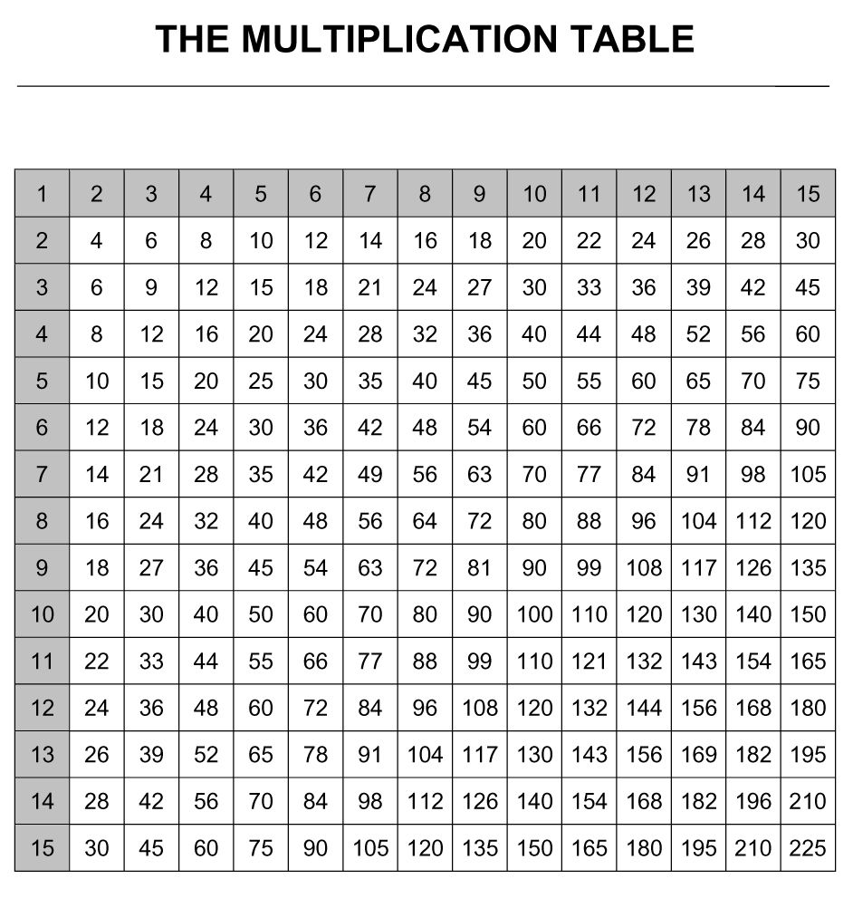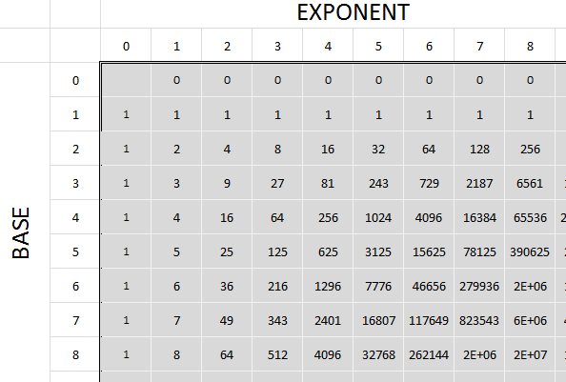

Table of Trigonometric Ratios
Angle   Sine    Cosine   Tangent   Angle   Sine    Cosine   Tangent

  1     .0175    .9998 ...